Date | Authorized Aircraft
05/31/19 | 412 RII Inspector

Maritime Helicopters, Inc.
RII INSPECTION AUTHORIZATION
This is to certify that Jeremy Lister certificate number 3742498 is authorized to exercise the privileges of the RII Inspector in accordance with the Maritime Helicopters CAMP, has demonstrated competency in this area and accepts the responsibilities of a Maritime Helicopters RII Inspector.
___________________________ ______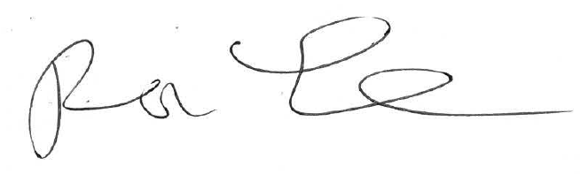_____
Technicians Signature Chief Inspectors Signature
_____________05/31/19___________
Date

