
Federal Aviation Administration
MMEL Policy Letter 76, Revision 7
Date: 12/04/2017
To: Manager, Aircraft Evaluation Division (AFS-100)
All Aircraft Evaluation Group Managers
From: Manager, Air Transportation Division (AFS-200)
Reply to Attn of: Manager, New Program Implementation Branch (AFS-240)
SUBJECT: ATC Transponders and Automatic Altitude Reporting Systems
MMEL CODE: 34 (NAVIGATION)
REFERENCE: PL-76, Revision 6, dated July 30, 2013
PL-76, Revision 5, dated March 24, 2008
PL-76, Revision 4, dated May 26, 2005
PL-76, Revision 3, dated November 7, 2003
PL-76, Revision 2, dated October 16, 2001
PL-76, Revision 1, dated August 15, 1997
PL-76, Original, dated January 11, 1995
Title 14 of the Code of Federal Regulations (14 CFR) part 91, §§ 91.130, 91.131, 91.135, 91.215, 91.219, Appendix G
PURPOSE:
The purpose of this Policy Letter is to provide standardized Master Minimum Equipment List (MMEL) requirements for Air Traffic Control (ATC) transponders and automatic altitude reporting systems.
DISCUSSION:
Revision 7: Removes the Automatic Dependent Surveillance-Broadcast (ADS-B) squitter transmissions relief (relief is provided in PL-105).
Revision 6: Revised the repair category for ADS-B squitter transmissions and added relief for when it is required by operations.
Revision 5: Added relief for ADS-B Extended Squitter Transmissions. Removed the word “Enroute” from all provisos.
Revision 4: Added relief for “Mode S Elementary and Enhanced Downlink Aircraft reportable parameters not required by FAR.” These parameters are required for operations in Europe.
Revision 3: Changed the relief category for operating without a transponder from “C” to “B”. This change was made in order to align it with Traffic Alert and Collision Avoidance System (TCAS) relief. TCAS relief is Category “B”, and the transponder is needed for TCAS.
Revision 2: Deleted the first set of the MMEL remarks in Revision 1 to clarify that there is no relief for ATC transponders and automatic altitude reporting systems required by 14 CFR. The remarks were also revised to indicate that operations in Reduced Vertical Separation Minimums (RVSM) require an operating altitude reporting transponder. Revision also deleted a discussion paragraph already stated in the purpose.
Revision 1: Reformatted Policy Letter 76 with no change to policy.
POLICY:
The following MMEL proviso and repair interval is adopted to provide standardization among all MMELs:
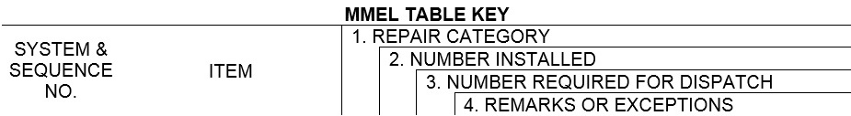
34. NAVIGATION

Sequence No. | Item | 1 | 2 | 3 | 4 | Change Bar
34-XX | ATC Transponders and Automatic Altitude Reporting Systems | B | - | 0 | May be inoperative provided:  - Operations do not require its use, and  - Prior to flight, approval is obtained from ATC facilities having jurisdiction over the planned route of flight.
 |  | D | - | 1 | Any in excess of those required by 14 CFR may be inoperative.
1)  *** | Elementary and Enhanced Downlink Aircraft Reportable Parameters Not Required by 14 CFR | A | - | 0 | May be inoperative provided:  - Operations do not require its use, and  - Repairs are made prior to completion of the next heavy maintenance visit.
Each Flight Operations Evaluation Board (FOEB) Chair should review the specific aircraft configuration(s) and apply this policy to affected MMELs through the normal FOEB process.
ORIGINAL SIGNED by
/s/ Stephen C. Moates for
Manager, Air Transportation Division

