

REPAIR STATION
FORMS MANUAL

For
FAA Approved Repair Station No ENRR619D
FAA Approved Satellite Repair Station No EN2D619D
DBA
Maritime Helicopters, Inc.
3520 FAA Road
Homer, Alaska 99603
(907) 235-7771

Published by:
Maritime Helicopters, Inc.
3520 FAA Road
Homer, AK 99603
(907) 235-7771

Copyright © 2013 Maritime Helicopters, Inc.
All Rights Reserved. No part of the contents of this document may be reproduced or transmitted in any form by any means without the written permission of Maritime Helicopters, Inc.
Record of Revisions

Rev No. | Rev Date | Change Summary | Received Via
Reissue | 11/01/2013 | All Pages | SDS
Rev 1 | 01/10/2015 | ii, iii, 3-1, 4-38, 4-39, 4-40 | SDS
Rev 2 | 5/01/2015 | Cover | SDS

List of Effective Pages

PAGE | STATUS | DATE |  | PAGE | STATUS | DATE |  | PAGE | STATUS | DATE
Cover | Rev 2 | 5/01/15 |  | 4-24 | Reissue | 11/01/13 |  | 5-14 | Reissue | 11/01/13
i | Reissue | 11/01/13 |  | 4-25 | Reissue | 11/01/13 |  | 5-15 | Reissue | 11/01/13
ii | Rev 1 | 01/10/15 |  | 4-26 | Reissue | 11/01/13 |  | 5-16 | Reissue | 11/01/13
iii | Rev 1 | 01/10/15 |  | 4-27 | Reissue | 11/01/13 |  | 5-17 | Reissue | 11/01/13
1-1 | Reissue | 11/01/13 |  | 4-28 | Reissue | 11/01/13 |  | 5-18 | Reissue | 11/01/13
2-1 | Reissue | 11/01/13 |  | 4-29 | Reissue | 11/01/13 |  | 5-19 | Reissue | 11/01/13
3-1 | Rev 1 | 01/10/15 |  | 4-30 | Reissue | 11/01/13 |  | 5-20 | Reissue | 11/01/13
4-1 | Reissue | 11/01/13 |  | 4-31 | Reissue | 11/01/13 |  | 5-21 | Reissue | 11/01/13
4-2 | Reissue | 11/01/13 |  | 4-32 | Reissue | 11/01/13 |  | 5-22 | Reissue | 11/01/13
4-3 | Reissue | 11/01/13 |  | 4-33 | Reissue | 11/01/13 |  | 5-23 | Reissue | 11/01/13
4-4 | Reissue | 11/01/13 |  | 4-34 | Reissue | 11/01/13 |  | 5-24 | Reissue | 11/01/13
4-5 | Reissue | 11/01/13 |  | 4-35 | Reissue | 11/01/13
4-6 | Reissue | 11/01/13 |  | 4-36 | Reissue | 11/01/13
4-7 | Reissue | 11/01/13 |  | 4-37 | Reissue | 11/01/13
4-8 | Reissue | 11/01/13 |  | 4-38 | Rev 1 | 01/10/15
4-9 | Reissue | 11/01/13 |  | 4-39 | Rev 1 | 01/10/15
4-10 | Reissue | 11/01/13 |  | 4-40 | Rev 1 | 01/10/15
4-11 | Reissue | 11/01/13 |  | 5-1 | Reissue | 11/01/13
4-12 | Reissue | 11/01/13 |  | 5-2 | Reissue | 11/01/13
4-13 | Reissue | 11/01/13 |  | 5-3 | Reissue | 11/01/13
4-14 | Reissue | 11/01/13 |  | 5-4 | Reissue | 11/01/13
4-15 | Reissue | 11/01/13 |  | 5-5 | Reissue | 11/01/13
4-16 | Reissue | 11/01/13 |  | 5-6 | Reissue | 11/01/13
4-17 | Reissue | 11/01/13 |  | 5-7 | Reissue | 11/01/13
4-18 | Reissue | 11/01/13 |  | 5-8 | Reissue | 11/01/13
4-19 | Reissue | 11/01/13 |  | 5-9 | Reissue | 11/01/13
4-20 | Reissue | 11/01/13 |  | 5-10 | Reissue | 11/01/13
4-21 | Reissue | 11/01/13 |  | 5-11 | Reissue | 11/01/13
4-22 | Reissue | 11/01/13 |  | 5-12 | Reissue | 11/01/13
4-23 | Reissue | 11/01/13 |  | 5-13 | Reissue | 11/01/13

DATE ACCEPTED: _____________________________ DATE ACCEPTED: _____________________________

_____________________________________________ _____________________________________________
FAA PRINCIPAL MAINTENANCE INSPECTOR FAA PRINCIPAL AVIONICS INSPECTOR
AK-FSDO-03 AK-FSDO-03

Table of Contents
RECORD OF REVISIONS I
List of Effective Pages ii
1 Introduction 1-1
2 Manual Revisions 2-1
2.1 Manual Revisions and Control 2-1
2.2 Paper Format 2-1
3 Forms Listing 3-1
3.1 Repair station Forms 3-1
3.2 Training Forms 3-1
4 REPAIR STATION FORMS 4-1
4.1 Part 145 Work Order Log – FORM MHI 001 4-2
4.2 Work Order Cover Sheet – FORM MHI 002 4-4
4.3 Repairable Parts Tag – Form MHI 004 4-7
4.4 Part 145 Work Sheet – FORM MHI 005 4-9
4.5 Serviceable Parts Tag – FORM MHI 006 4-11
4.6 Rejected Part Tag – Form 0007 4-13
4.7 Identification Tag - FORM MHI 008 4-15
4.8 Routing Tag – FORM MHI 009 4-17
4.9 Non Destructive Testing Parts Tag – FORM MHI 010 4-18
4.10 NDT Inventory Log – FORM MHI 011 4-20
4.11 Receiving Inspection Log – FORM MHI 012 4-22
4.12 Shelf Life Audit – FORM MHI 013 4-24
4.13 Summary of Employment – FORM MHI 016 4-25
4.14 Capabilities Self Evaluation Checklist – FORM 017 4-27
4.15 Calibration Sticker (sample) – FORM MHI 018 4-30
4.16 Tool Calibration 4-31
4.17 Revision Notice Acknowledgement Form MHI 019 4-32
4.18 Master Manual Distribution List - Form MHI 020 4-34
4.19 Mechanic Signature/Initial Roster Form MHI 021 4-37
4.20 Altimeter 24 Month Checklist Form MHI 022 4-38
4.21 Transponder 24 Month Checklist Form MHI 023 4-40
5 TRAINING FORMS 5-1
5.1 Training Request Form TR-0003 5-2
5.2 Training Activity Report Form TR-0004 5-4
5.3 Training Verification - Form TR-0005 5-6
5.4 Training Course List - Form TR-0006 5-8
5.5 Course-Lesson Information - Form TR-0007 5-10
5.6 Employee Skill Survey - Form TR-0008 5-12
5.7 Repair Station Needs Assessment - Form TR-0009 5-15
5.8 Instructor/Trainer Evaluation - Form TR-0010 5-17
5.9 Course Evaluation - Form TR-0011 5-20
5.10 Training Activity Make Up Form - TR-0012 5-23

Introduction

This Repair Station Forms Manual (RSFM) has been prepared in accordance with the current regulations contained in Title 14 CFR §145, and is a prerequisite for operation under the privileges of the Repair Station certificate. The validity of the Repair Station’s certificate is directly dependent upon compliance with the procedures and requirements within this manual, as well as, the associated Repair Station and Quality Control Manuals.

MHI Repair Station will not maintain or alter any article for which it is not rated, and will not maintain or alter any article for which it is rated if it requires technical data, equipment, materials, facilities or trained personnel that are not available.

A current copy of this RSFM, including the associated Repair Station and Quality Control Manuals, shall be accessible to applicable Repair Station personnel. A current copy of the required Repair Station Forms Manual and any revisions made will also be provided to the FAA Certificating Holding District Office (CHDO).

Manual Revisions
The Accountable Manager oversees the creation and revision of MHI controlled documents. Department Managers and Supervisors may submit suggestions and corrections for incorporation into this manual by contacting the Chief Inspector. Changes made to this manual will be summarized in the change summary table and indicated throughout the manual by change bars. A vertical bar (change bar) in the right margin indicates a change, addition, or deletion in the adjacent text for the current revision of that page only. The change bar is dropped at the next revision of that page.

Manual Revisions and Control

The Chief Inspector is responsible for the content of this manual and any revisions. This manual requires FAA acceptance prior to release. Revisions to this manual must be routed for MHI internal and FAA acceptance prior to distribution. This manual cannot be published or distributed to end users prior to formal submission to and acceptance by the FAA.

The Part 145 Accountable Manager shall be responsible to maintain MHI Master Manual Distribution List Form MHI 020, listing individuals that have been assigned manuals in paper format. The listing shall indicate the name of the individual, name of the manual, manual number, revision number, and the date the completed Revision Notice/Acknowledgment, Form MHI 019 was received.

Paper Format

Hard copy manuals shall be issued by the Part 145 Accountable Manager under a manual control number and revision notification controlled by the Revision Notice/Acknowledgment, Form MHI 019 indicating receipt of revision and incorporation into the manual. Manual holders shall be responsible to insert revisions, update the Record of Revisions page by entering the Revision Number, Date, Date Inserted, Revisions Inserted By, and return the completed Revision Notice/Acknowledgment, Form MHI 019 to Part 145 Accountable Manager to indicate the manual has been revised.

Forms Listing

Repair station Forms
Form # | Description
MHI 001 | Work Order Log
MHI 002 | Work Order
MHI 003 | TBD
MHI 004 | Repairable Parts Tag
MHI 005 | Part 145 Work Sheet
MHI 006 | Serviceable Parts Tag
MHI 007 | Rejected Parts Tag
MHI 008 | Identification Tag
MHI 009 | Routing Tag
MHI 010 | NDT Parts Tag
MHI 011 | NDT Inventory Log
MHI 012 | Receiving Inspection Log
MHI 013 | Shelf Life Audit
MHI 014 | TBD
MHI 015 | TBD
MHI 016 | Summary of Employment
MHI 017 | Capabilities Self Audit
MHI 018 | Calibration Sticker
MHI 019 | Revision Notice/Acknowledgment
MHI 020 | Master Distribution List
MHI 021 | Signature/Initial Roster
MHI 022 | Altimeter 24 Month Checklist
MHI 023 | Transponder 24 Month Checklist

Training Forms
Form # | Description
TR-0001 | TBD
TR-0002 | TBD
TR-0003 | Training Request
TR-0004 | Training Activity Report
TR-0005 | Training Verification
TR-0006 | Training Course List
TR-0007 | Course-Lesson Information
TR-0008 | Employee Skill Survey
TR-0009 | Repair Station Needs Assessment
TR-0010 | Instructor / Trainer Evaluation
TR-0011 | Course-Evaluation
TR-0012 | Training Activity Make Up

REPAIR STATION FORMS

Part 145 Work Order Log – FORM MHI 001
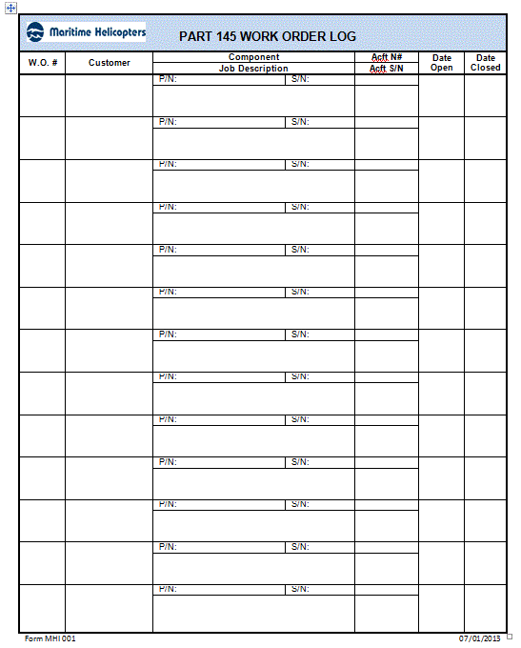

Instructions: Part 145 Work Order Log

This form will be used to log work on aircraft and articles. The Quality Assurance Department will initiate work orders. After the work order is closed, the QA Department completes the closed date. Complete the fields as follows:

W.O.# | Fill-in the work order number
Customer | Enter the customer’s name
Component Info  P/N:  S/N: | For an article, enter the article’s part number or assembly part  number; for aircraft, leave blank  For an article, enter the article’s S/N or assembly S/N; for aircraft, leave blank.
Job Description | Enter the job description from the discrepancy on the Component record tag, or an abbreviated version from the SOW for an aircraft
Aircraft N# | For an aircraft, enter aircraft registration number. For an article, enter  the registration number of the aircraft from which the article was removed.
Aircraft S/N | Enter serial number of the aircraft from which the article was removed as shown on the Component record tag.
Date Open | Enter date the work order was opened (when the preliminary inspection was performed).
Date Closed | Enter date the work order was closed (when article or aircraft returned to service or was rejected).

Work Order Cover Sheet – FORM MHI 002
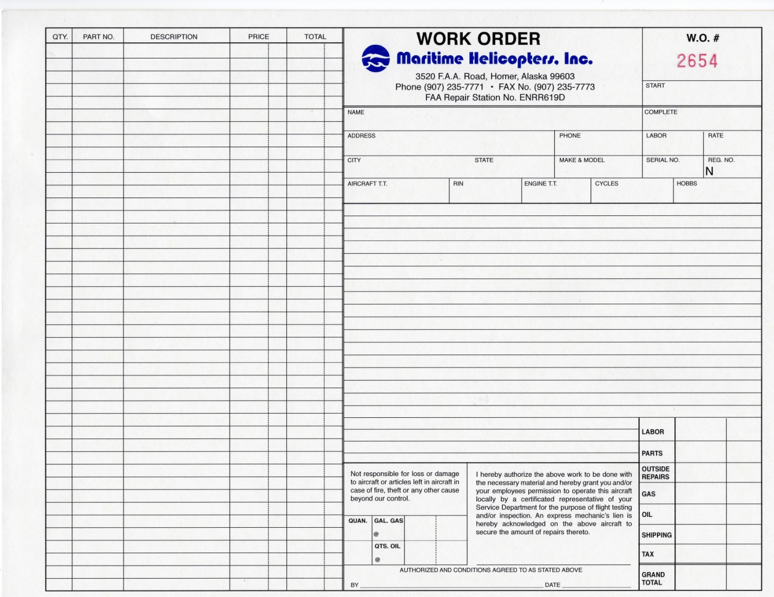
Form 002 07/01/2013
Instructions: Work Order Cover Sheet

This form shall be utilized to document the aircraft information and work to be performed. Complete the fields as follows:

Date W.O. Opened | Date the work order was opened
Customer Name | Customer’s name
Date W.O. Closed | Date the work order was closed
Address | Street address of company
Phone | Contact phone number
Labor | Total mechanic hours
Rate | Agreed upon shop rate
City & State | City & state of customer address
Make & Model | For example, 'Bell 407’
Serial # | For the aircraft, refer to the SOW. For an article, refer to the serviceability tag and enter the S/N of the aircraft from which the article was removed or the article’s S/N..
N# | For the aircraft, refer to the SOW. For an article, refer to the serviceability tag. Enter N# of the aircraft from which the article was removed.
Total Time | The total time for an aircraft. For an article, the aircraft’s total flight time at time of removal.
RIN | Fill in cycles, landings, or flights for articles or assembly (as applicable)
Engine TT | Total time of aircraft engine
Cycles / Starts | Engine/prop can be found on serviceability tag, status report, or logbook.
Hobbs | Total Hobbs tine from aircraft meter
Total Landings | For the aircraft and for an article, enter the total aircraft landings at time of removal (if applicable)

COMPONENTS

Name | Common abbreviations are acceptable (i.e. M/R, T/R, G/B, Assy, etc.)
Part # | Part number of the article from serviceability tag. If there are multiple articles, write "See below" and list the part numbers with each specific article in the Job Description.
Serial # | Serial number of the article from serviceability tag. If there are multiple articles, write "See below", list the serial numbers with each specific article in the job description.
Total Time/TSO | Applicable total time (since new) of the article or time since overhaul. If there are multiple articles, write “See below”, list the times with each specific article in the job description.

JOB DESCRIPTION

Item No. | For sequential itemization of different jobs (i.e. multiple articles: #1,#2,#3, etc.).
Description | Fill in the job description from the discrepancy on the Component record tag or an abbreviated version from the TSD or SOW for an aircraft. For more than one article, include the P/N, S/N, Name and applicable TSN/TSO times.

INSPECTIONS

Preliminary | A preliminary inspection MUST BE PERFORMED on any aircraft or article prior to maintenance being performed. Initials in this box stating an inspection was performed. If a preliminary discrepancy(s) was/were found, write up discrepancies(s) were found in box.
Hidden Damage | The QA inspector shall write up any hidden damage if found. If no hidden damage is found, write "N/A" for any hidden.
Continuity | QA Inspector initials. “See Attached” - continuity forms were used; “No” if continuity forms were not used.
Maintenance Final | Shall be initialed by the assigned Lead or Supervisor upon completion of work performed.
QA Final | The QA inspector shall acknowledge that the work order has had a final review prior to being closed and write in that statement.

MAINTENANCE RELEASE

Work Order No. | Write the work order number
Date | Enter the date the aircraft or article is returned to service
Signed | Authorized QA inspector signs prior to returning the aircraft or article to service.
Address | Fill in the appropriate address and CRS number of the MHI operated repair station returning the article to service.
FAA CRS # | Enter the CRS Number.

Repairable Parts Tag – Form MHI 004

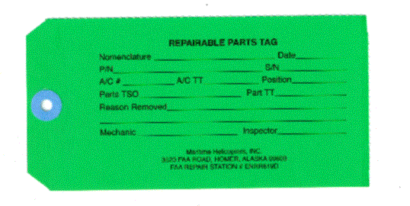

Instructions: Repairable Parts Tag

This tag shall be utilized to record the information of a repairable article. It is initiated by a mechanic. It will remain with the article until the article is rejected or made serviceable.

Date | Date of removal.
Part Name | Part name.
Part No. | Part number.
Serial No. | Part serial number.
Total Time | Total time of part.
TSO | If applicable.
RIN | If applicable.
CYC | If applicable.

Aircraft N# | Aircraft registration number.
TT | If applicable.
Remarks | Information of why the part is repairable.
Signature | Signature required of the QA inspector or the mechanic initiating the tag.
Cert Type & No | Enter the applicable repair station number if signing for the MHI repair station.

Part 145 Work Sheet – FORM MHI 005
Sample: Maintenance Discrepancy and Work Record

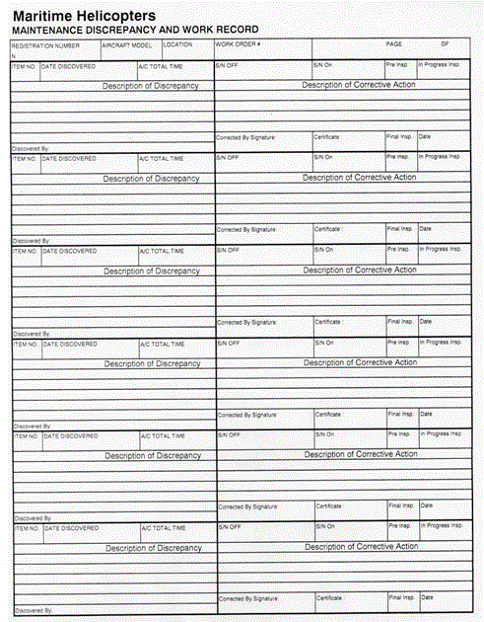

Instructions: Maintenance Discrepancy and Work Record

This form shall be utilized to document discrepancies and corrective actions. Upon completion, this form will become part of the work order package.

Aircraft No. | Enter aircraft registration number.
Aircraft Model | For example, 'Bell 407’
Location | Where maintenance is being performed at
Work Order No | Found at the top of the form 5087
Page No. | Page number if multiple pages are used.
Item # | Item # for sequential itemization of different tasks to be performed (i.e. for multiple steps: #1, #2, #3, etc.).
Date discovered | The person that entered the discrepancy must input date of the entry.
Acft TT | Aircraft total current airframe time
Description | Use this space to describe the removal or discrepancy.
Corrective Action | State the installation/corrective action within the section provided. References must satisfy requirements per CFR 14 § 43.13. i.e. M.M, dwg, ICA.
Discovered by | Mechanic who found the discrepancy will enter their initials
Corrective by signature | The mechanic that entered the corrective action will enter their initials.
Certificate | Mechanics certificate number (may be Repair Station number)
Final Insp | QA inspector will enter their initials if all work has been completed satisfactorily.
In progress inspection | If item is being inspected as part of a larger assembly

Serviceable Parts Tag – FORM MHI 006

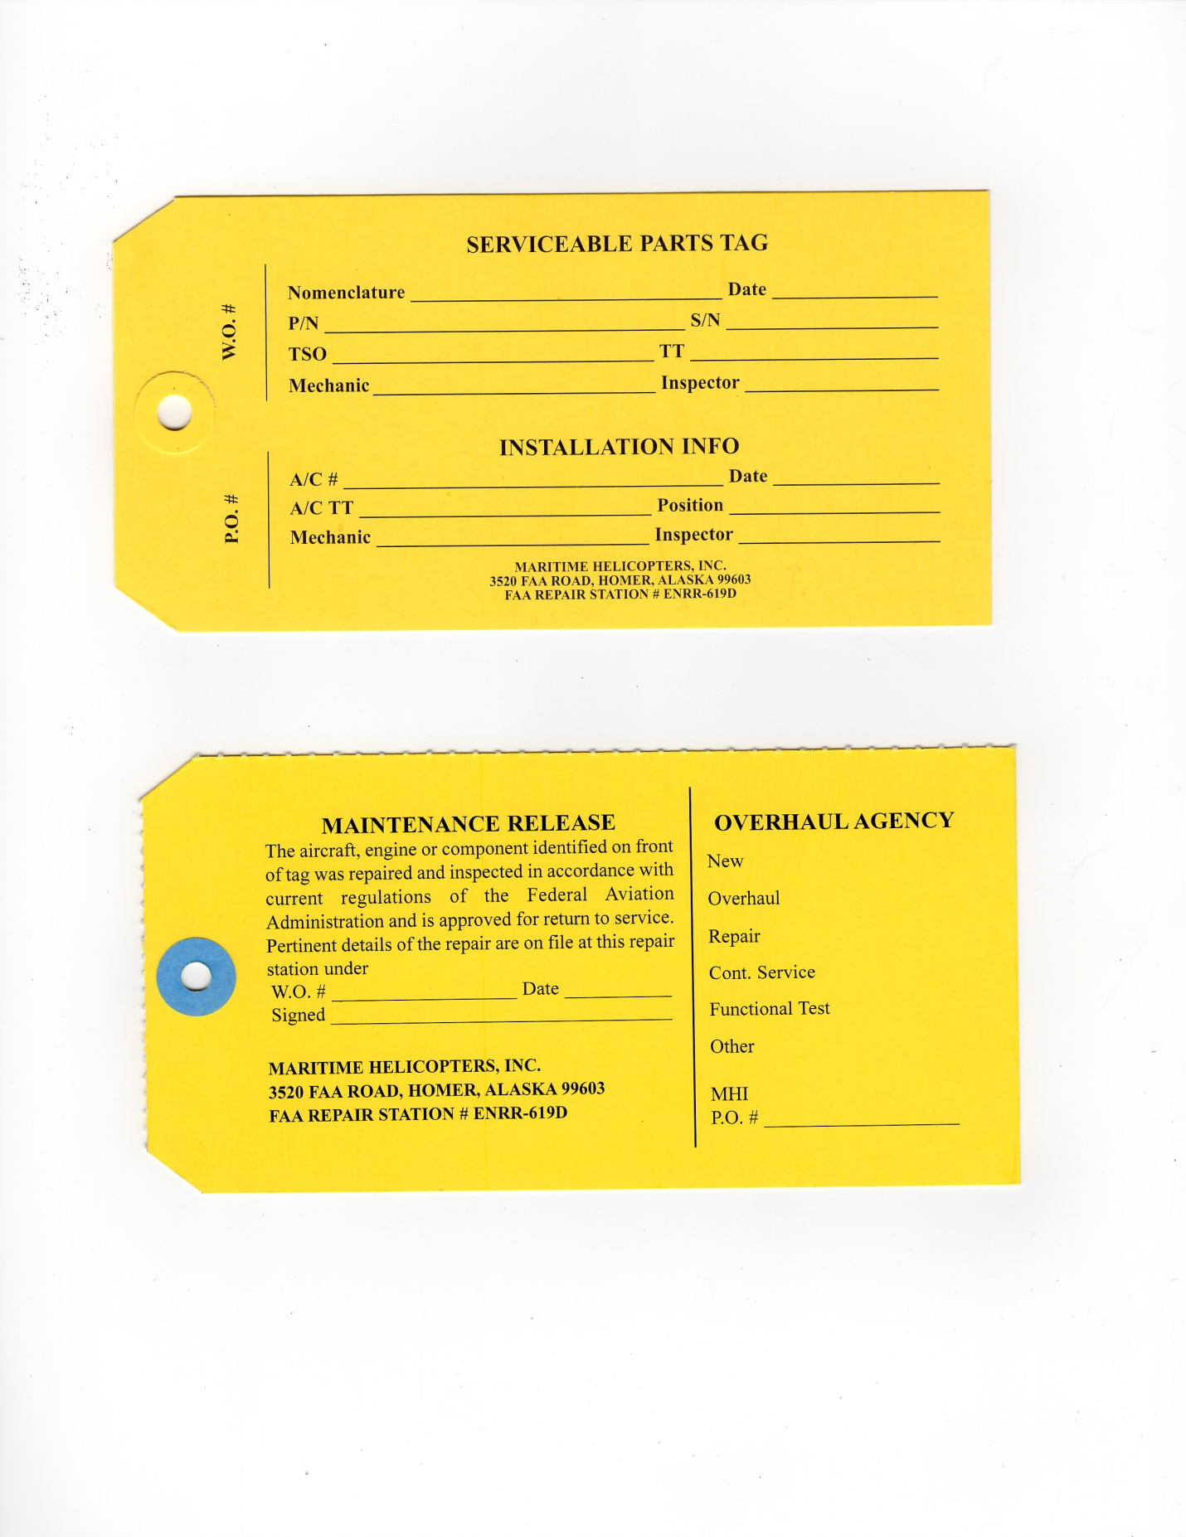

Instructions: Serviceable Parts Tag

This tag shall be utilized to record the information of a serviceable article. It is initiated by a mechanic. It will remain with the article is installed.

Nomenclature | Part name.
Date | Date of serviceability.
Part No. | Part number.
Serial No. | Part serial number.
TSO | Time Since Overhaul if applicable.
Total Time | Total time of part. Also enter a RIN count if applicable
Mechanic | Signature required of the mechanic removed the part.
Inspector | Signature required of the QA inspector or the mechanic condemning the part.
INSTALLATION INFO
Aircraft N# | Aircraft registration number.
Date | Date of installation.
Acft TT | Current aircraft airframe total time
Position | I.e. L/H, Upper, etc.
Mechanic | Installing mechanic name
Inspector | Installation Inspector
MAINTENANCE RELEASE
W.O # | Work Order number (if applicable)
Date | Date of Release.
Signed | Signature of releasing inspector
OVERHAUL AGENCY
 | Circle status of part. i.e., new, overhauled, repaired, etc.
MHI PO# | Enter MHI Purchase Order number

Rejected Part Tag – Form 0007
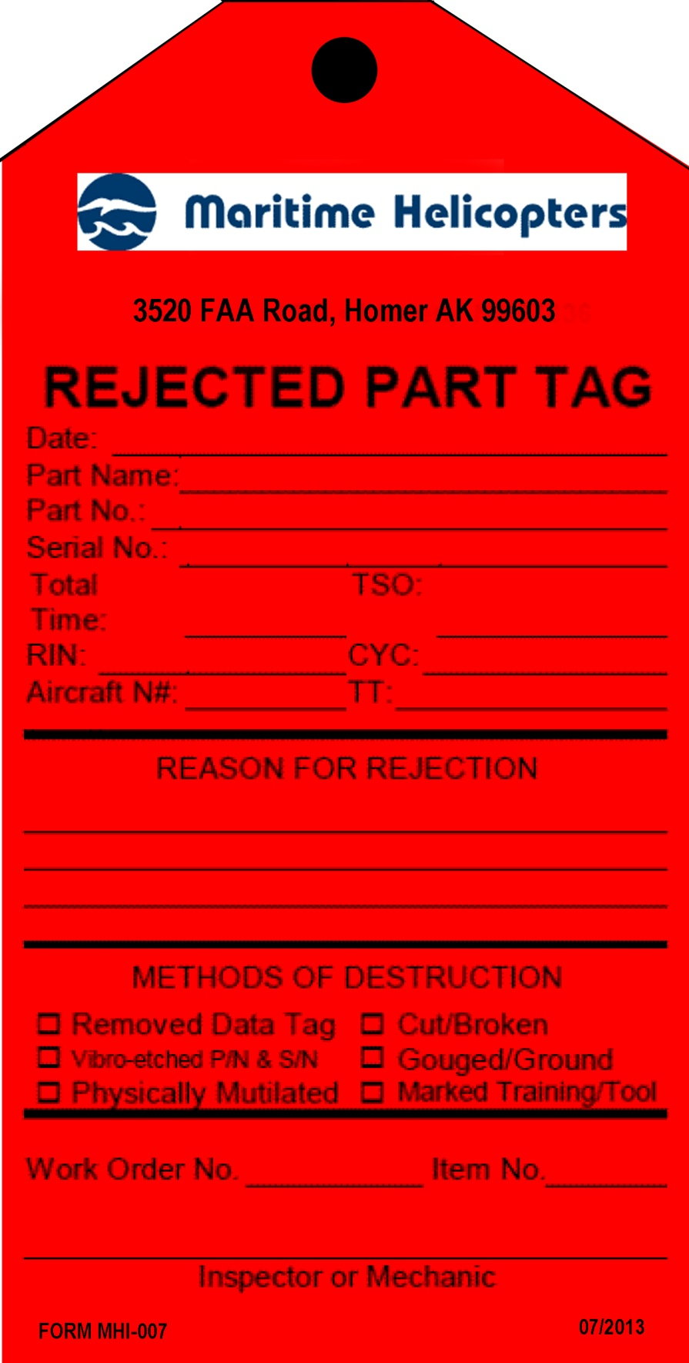

Instructions: Rejected Part Tag

This tag shall be utilized to record the information of a rejected article. It is initiated by a mechanic. It will remain with the article until the article is destroyed or mutilated.

Date | Date of rejection.
Part Name | Part name.
Part No. | Part number.
Serial No. | Part serial number.
Total Time | Total time of part.
TSO | If applicable.
RIN | If applicable.
CYC | If applicable.

Aircraft N# | Aircraft registration number.
TT | If applicable.
Reason | The reason for rejection must include a detailed explanation of why the part is not serviceable.
Methods Destr. | Record methods used to render the part un-usable. Prior to destruction, ensure parts are not to be returned to the owner.
Work Order No | Work order number.
Item No | Discrepancy item in the work order originally rejecting the part.
Inspector/Mech | Signature required of the QA inspector or the mechanic condemning the part.
Cert Type & No | Enter the applicable repair station number if signing for an HFS operated repair station.

Identification Tag - FORM MHI 008
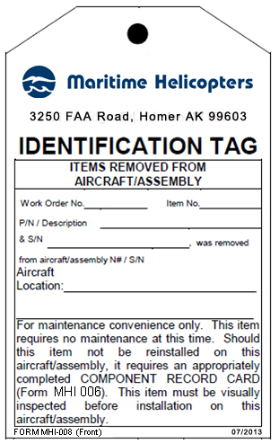

Instructions: White Identification Tags

This tag shall be utilized to identify articles or shelving/storage units as required. It is initiated by a mechanic. This tag may be discarded when the component(s) is reinstalled on the same aircraft or identification tag is replaced by a component record card (form MHI 006).

Work Order No. | Enter work order No. from applicable form MHI 002.
Item No. | Enter discrepancy item number from form MHI 005.
P/N Description | Enter part number of article and describe.
& S/N | Enter article serial number.
Removed from N#/S/N | Enter next higher assembly information.

Side One: ITEMS REMOVED FROM AIRCRAFT / ASSEMBLY

With the information on this side completed, the tag shall be attached to indicate a serviceable article’s removal from an aircraft "for maintenance convenience only”. This shall be attached to the individual item. Should the individual articles labeled with an "Identification Tag,” form MHI 008, require any maintenance, a green routing tag, form MHI 009 will be completed as well as a work order discrepancy card entry on form MHI 005. If the removed article is not to be reinstalled on the original aircraft, it requires the article to be tagged with a component record tag (form MHI 006).
NOTE: No item removed and tagged with a white Identification Tag, form MHI 008 will be reinstalled unless the item is deemed “serviceable” by an appropriately rated mechanic.

Side Two: ALL ITEMS PLACED ON OR IN THIS STORAGE UNIT SIDE

With the information on this side completed, the tag shall be utilized to identify shelves, racks and containers.
In the case of cabin interiors (seats, upholstery, etc.), empennage or fuselage cowls, inspection/access panels, hardware, and other similar items, such parts must be serviceable and will be segregated on shelves, racks or in containers labeled as appropriate with one identification tag.

Routing Tag – FORM MHI 009

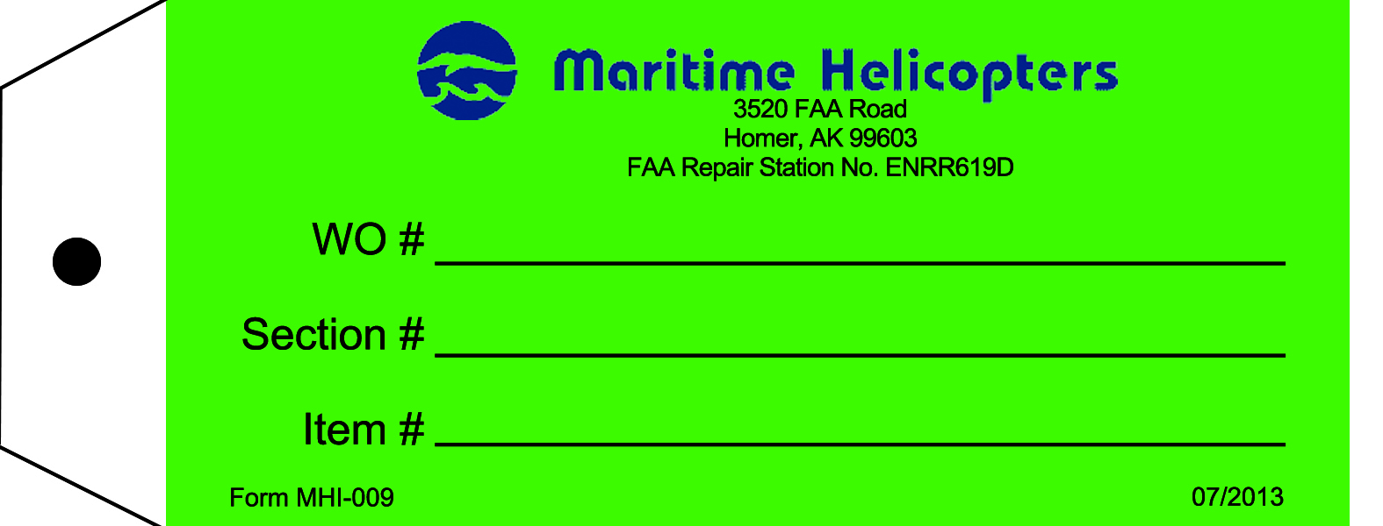

Instructions: Green Routing Tag

This tag shall be utilized when an article is removed from the aircraft, article, storage rack, or shelf for maintenance or alteration under the work order. It is initiated by a mechanic. Upon completion of the inspection, this tag will be destroyed by the QA inspector. Complete the fields as follows:

Work Order # | Work order number.
Section # | Section number (of the aircraft work order).
Item # | Discrepancy number as found on the form MHI 005 discrepancy card.

Non Destructive Testing Parts Tag – FORM MHI 010
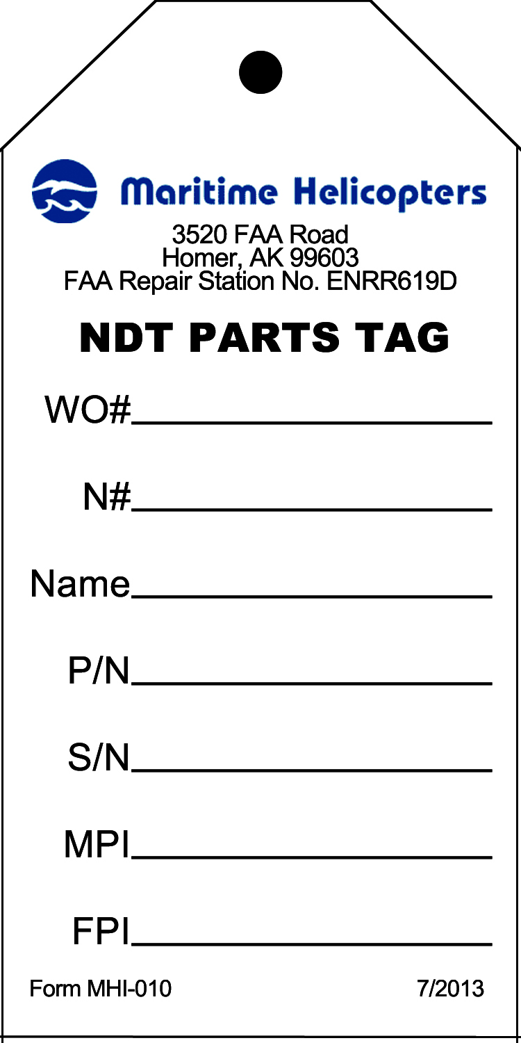

Instructions: Non Destructive Testing Parts Tag

This tag is used to identify articles leaving an MHI repair station for non-destructive testing. It is initiated by a mechanic. After work is performed by the vendor this form is no longer required for the work order package.

WO # | Assigned work Order number from form MHI 002.
N# | Aircraft’s registration number.
Name | The given nomenclature/name of the article (i.e. “Sun Gear”).
P/N | Part number of the article.
S/N | Serial number of the article. If there is no serial number use “NA”.
MPI | X on line indicating if a magnetic particle inspection is required.
FPI | X on line indicating if a fluorescent penetrant inspection is required.

NDT Inventory Log – FORM MHI 011
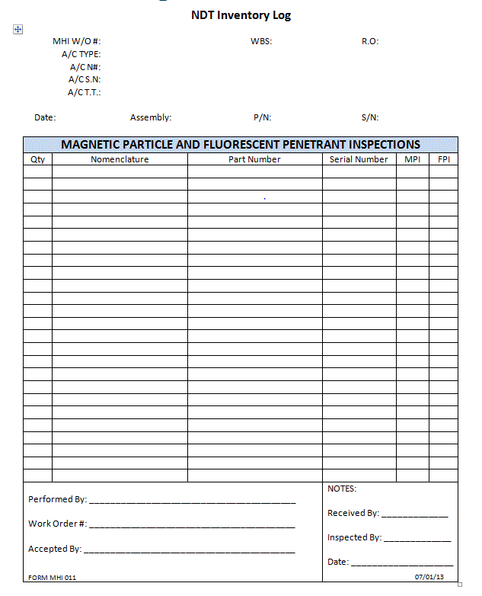
Instructions: Non Destructive Testing (NDT) Inventory Log

This form is an inventory log of articles sent for non-destructive testing. It is initiated by a mechanic. It will be archived with the work order package.

Note: Leave no blanks – use ‘N/A’ if not required or not applicable.

W/O # | Work order number assigned on form MHI 002
A/C Type | Aircraft type (i.e. “Bell 407”).
A/C N# | Aircraft’s registration number.
A/C S/N | Aircraft’s serial number.
A/C T.T. | Aircraft’s total time.
Date | Date the form was initiated.
Assembly | Higher assembly’s nomenclature, if applicable (i.e. “Main Transmission”).
S/N | Serial number of the higher assembly, if applicable.
Qty | Number/quantity of pieces for the given article.
Nomenclature | Given nomenclature of the article (i.e. “Sun Gear”).
Part Number | Enter the part number of the article.
Serial Number | Enter the serial number of the article. If there no serial number, use “NSN” (“No Serial Number”).
MPI | “X” in the appropriate box if this type of inspection is required for the article.
FPI | “X” in the appropriate box if this type of inspection is required for the article.
Performed By | For vendor use only.
Work Order # | For vendor use only.
Accepted By | For vendor use only.
Notes | Use this space to note anything unusual or noteworthy. If no notes, enter “N/A”.
Received, Inspected By | Individual(s) receiving and inspecting the article must sign/date here.

Receiving Inspection Log – FORM MHI 012

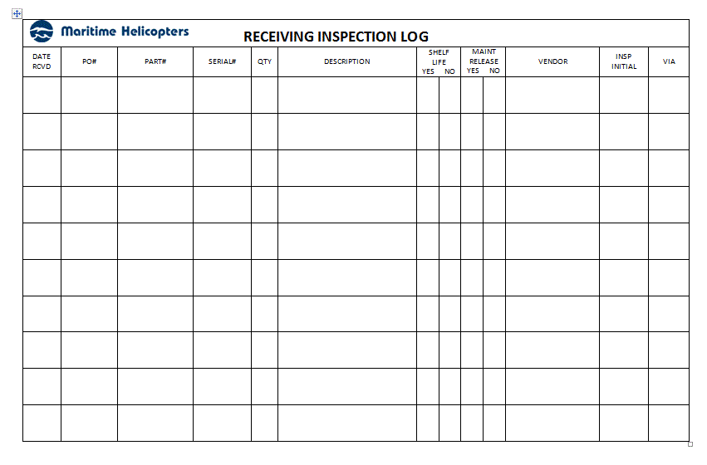

Instructions: Receiving Inspection Log

This form provides a record of articles received into the repair station. It is initiated by an incoming/receiving Inspector. The form is to be archived in the incoming and receiving area.

Date Received | Supplying vendor name as stated on invoice.
PO# | PO number as stated on invoice.
Part # | Number of part.
Serial # | Serial number affixed to part.
QTY | Total number of parts received as stated on invoice.
Description | As stated on invoice.
Shelf Life | Indicate YES or NO whether shelf life is limited.
Maint Release | Indicate YES or NO whether maintenance release was supplied with unit.
Vendor | Name of company supplying the parts.
Insp Initial | Initials of incoming and receiving inspector completing the inspection.
Pickup | Initials of mechanic or individual receiving or picking up the part from the receiving area after the completion of the Incoming Inspection.

Shelf Life Audit – FORM MHI 013

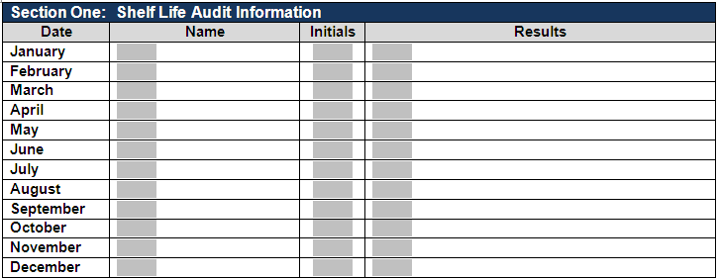

Instructions: Shelf Life Audit Sheet

This form documents that an audit of shelf life items in the storage unit was performed. It will be initiated by the person responsible for monitoring MHI operated repair station shelf life products. Shelf Life audits are to be conducted by the end of each month. This form will be discarded upon initiation of a new, annual form.

Date | Day the audit is accomplished for the appropriate month.
Name | Printed name of individual performing the audit.
Initials | Individual’s initials.
Results | Brief description of results.

Summary of Employment – FORM MHI 016

Name:_____________________________________________________________

Scope of Assignment: Maritime Helicopters Maintenance

Present Title:________________________________________________________

Years experience in this type work:______________________________________

Past employment record: (at least 5 years)

From: | To: | Place: | Type of Work | Position

Authorized to sign: All Inspections & Maintenance per MHI Inspection Procedures Manual

Type and number of FAA Certificate(s) now held:

1. ____________________________________________________________________________

2. ____________________________________________________________________________

3. ____________________________________________________________________________

Instructions: Summary of Employment

This form shall be utilized to capture information required by Title 14 CFR §145.161(a)(4) for management, supervisory, inspection, and return to service personnel. For all other repair station positions, this is optional. This shall be maintained by the Chief Inspector during the individual’s period of employment.

Employee Name | Name
Scope | Define scope of present employment.
Employee Title | Title
Experience | Number of years in this type of work
Past Employment | Enter past 5 years of experience
Dates of Employ | Dates of previous employment
Type of Mntn Performed | Types of maintenance work performed (attach add’l sheets)
Type FAA Certification | FAA Certificates currently held (A&P, IA, Repairman, etc.)
Cert Number | Certification Numbers

Capabilities Self Evaluation Checklist – FORM 017
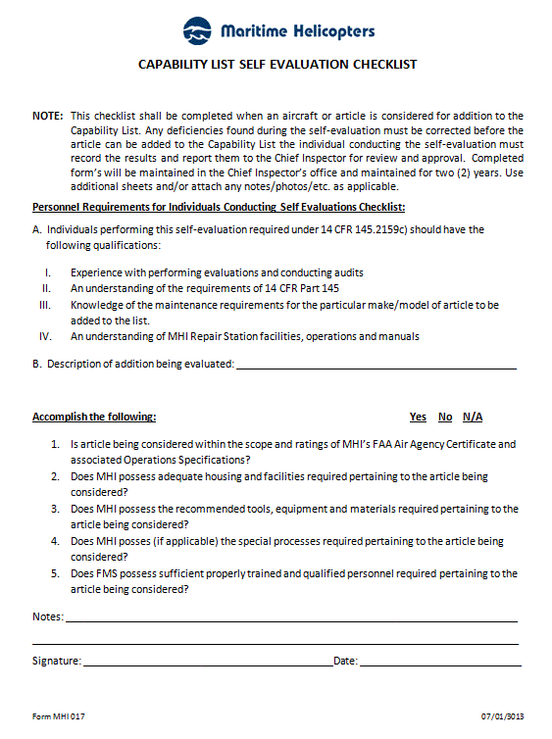

Instructions: Capabilities Self Evaluation Checklist

This form shall be utilized for the purposes of performing a self-evaluation prior to modifying the Repair Station Capabilities List. This self-evaluation shall also be utilized for the purpose of performing an annual review of the capabilities. Attachments may be utilized if needed for additional information.

Evaluation is to Indicate the nature of the Self Evaluation (Add, Delete, Modify an existing capability, or perform an Annual Review).

Manufacture Self Explanatory

Model Number Enter manufactures model number. If there is no model number then enter N/A.

Part Name Enter the manufacturers name for the part or assembly. If capability is not part number specific then enter N/A.

Part Number Enter the manufactures specific part or assembly number. If capability is not part number specific then enter N/A.

Capability to Enter the applicable Capability to be performed
be Performed

FAA Ratings Enter the applicable FAA Ratings that are affected by this evaluation.
Affected

Manufacturers The documentation required per CFR §145.109(d) shall be verified as accessible and
Documentation current. The required manufactures manuals shall be entered within the chart once
verified. Access to manufactures Service Bulletins (SB) and FAA Airworthiness
Directives (AD) once verified shall be entered into chart. This entry need not list each
individual SB or AD but may be entered as a single line entry such as "Bell Helicopter
Canada BH-407 Service Bulletins" or "FAA Airworthiness Directives"

Manual Review Perform a review of the Repair Station Manual System and verify if this request requires any revisions to be made. Any revisions required must be in place prior to
performing the requested functions. Indicate YeslNo.

Equipment, Tools, The required manufactures tooling, equipment and materials shall be verified as
Materials, Facilities, onsite or readily accessible. If equivalent tooling is to be utilized, It must have an
And Processes equivalency evaluation performed prior. Calibration requirements must be verified as current. Verify if adequate facilities are available per CFR §145.103. Verify if any Special Processes are required, and if so does the repair station have the
ability to either perform those processes or have it complied with by an outside entity. Indicate YeslNo.

Trained Personnel/ Verify if there is adequate trained maintenance, inspection, and supervisory
Supervisory Staff personnel available. Verification may include: documented training, OJT, or experience. All trained individuals or supervisors are not required to be entered on the chart, only the minimum needed to perform the capabilities requested.

Approvals/Denials Check as applicable: Approved, Deleted, Annual Review Completed, or Denied.

Approval Upon review of the findings of this evaluation checklist, the Part 145 Accountable Manager and the Chief Inspector, or their designee, shall sign.

Calibration Sticker (sample) – FORM MHI 018
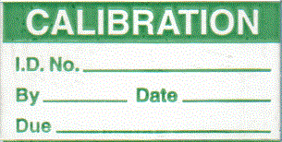

Instructions: Calibration Sticker

This is used as a replacement sticker on a calibrated tool in the event the original sticker is lost or damaged. The wording and size of information might vary in order to fit the necessary information on the sticker and too. This sticker is to remain on the calibrated tool until the tool is recalibrated.

ID Number Enter I.D. No. of the tool (Either model number or S/N)

By Initials of person performing the calibration

Date Enter date of calibration

Date due Enter tool re-calibration due date

Tool Calibration
Description | Owner | Part Number | Serial Number | Service Life | Date Inspected | Date Due

Instructions: Tool Calibration

This is used as a replacement sticker on a calibrated tool in the event the original sticker is lost or damaged. The wording and size of information might vary in order to fit the necessary information on the sticker and too. This sticker is to remain on the calibrated tool until the tool is recalibrated.

Description Enter the name of the tool
Owner Enter company or mechanics name
Model Enter tool manufacturer’s model number
P/N Enter tool part number
S/N Enter serial number of tool
Date Inspected Enter date tool was inspected
Date due Enter tool re-calibration due date

Revision Notice Acknowledgement Form MHI 019
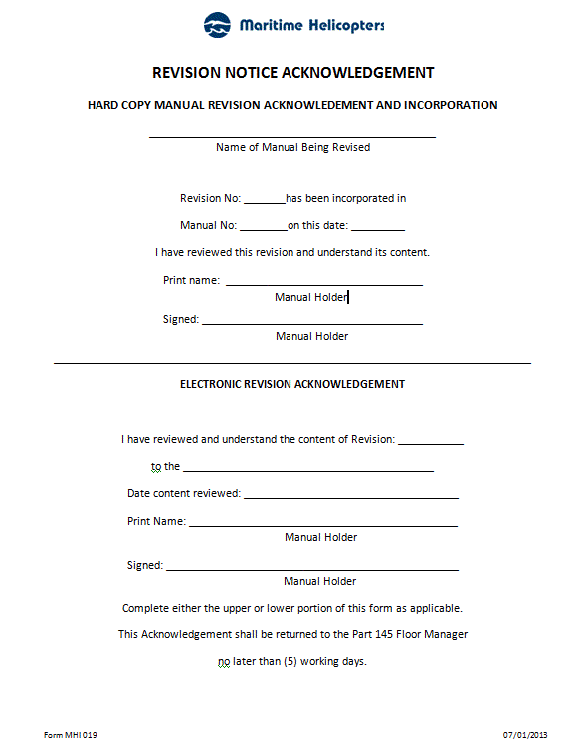

Instructions for completion of Revision Notice Acknowledgement Form MHI 019:

1. Name of manual being revised (i.e. Repair Station Manual, Quality Control Manual, etc.)
2. Revision number (i.e. 01, 03, etc.)
3. Manual number of assigned holder
4. Date that manual was revised and content reviewed
5. Printed name of manual holder (i.e. John Doe, etc.)
6. Signature of individual indicating that revision was completed, and content reviewed and understood
7. When an electronic manual revision is performed, enter the applicable Revision number
8. Name of affected manual that was revised (i.e. Repair Station Manual, Quality Control Manual, etc.)
9. Date that content of revision was reviewed
10. Printed name of manual holder (i.e. John Doe, etc.)
11. Signature of individual indicating that content of revision was reviewed and understood
12. Name of manual being requested for proposed revision (i.e. Repair Station Manual, Quality Control Manual, etc.)
13. Section of applicable manual where proposed revision is being suggested
14. Page number of applicable manual where proposed revision is being suggested
15. Describe details and content of proposed revision
16. Name of individual that is requesting the proposed revision
17. Phone contact information of individual that is requesting the proposed revision
18. Details of the disposition provided by the Chief Inspector in regards to the proposed revision
19. Once the disposition has been completed, the Chief Inspector will sign and enter date

Master Manual Distribution List - Form MHI 020
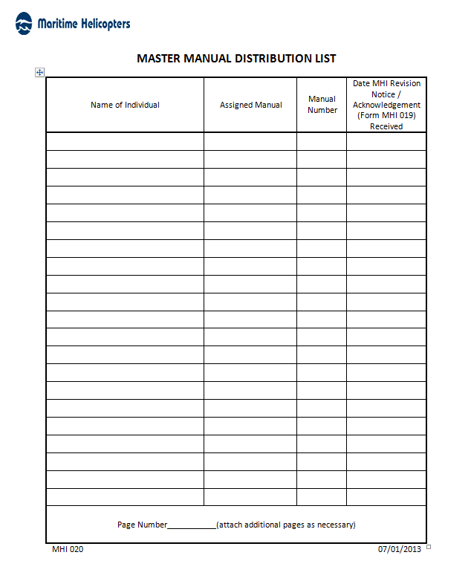

Instructions for completion of Master Manual Distribution List Form MHI 020:

1. Name of individual (i.e. John Doe, etc.) that manual is assigned to
2. Nomenclature of assigned manual (i.e. Repair Station Manual, Quality Control Manual, etc.)
3. Manual number (i.e. 01, 02, 03, etc.)
4. Revision number of manual (i.e. Original, 01, 02, 03, etc.)
5. Date that completed Revision Notice / Acknowledgment (Form TL-0003) was received
6. Enter page number

Mechanic Signature/Initial Roster Form MHI 021
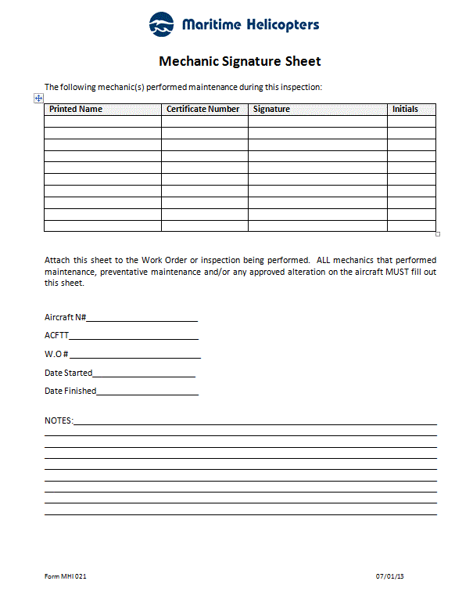

Altimeter 24 Month Checklist Form MHI 022
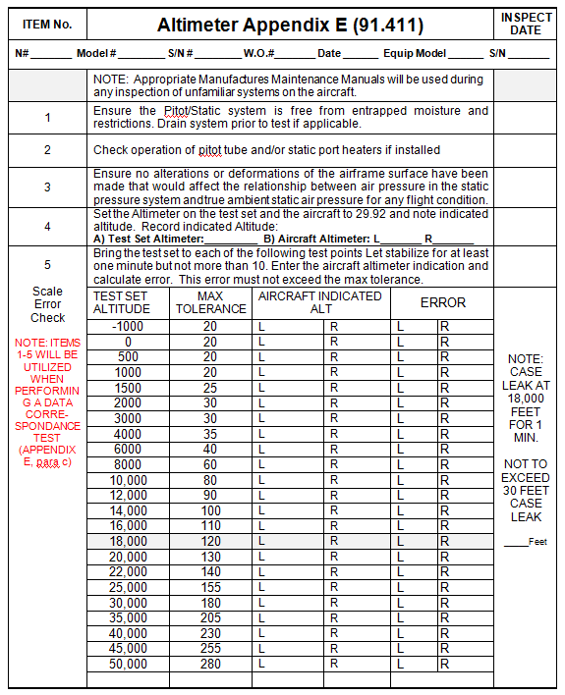

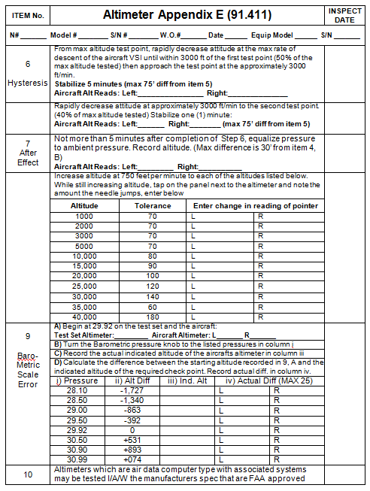

Transponder 24 Month Checklist Form MHI 023

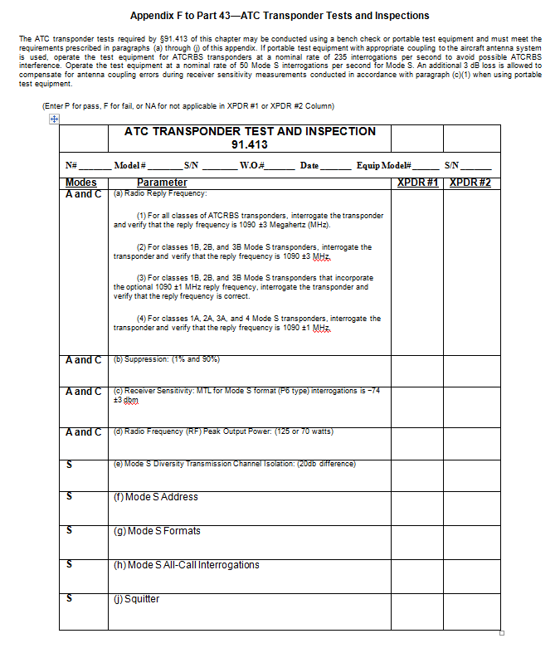

TRAINING FORMS

Training Request Form TR-0003
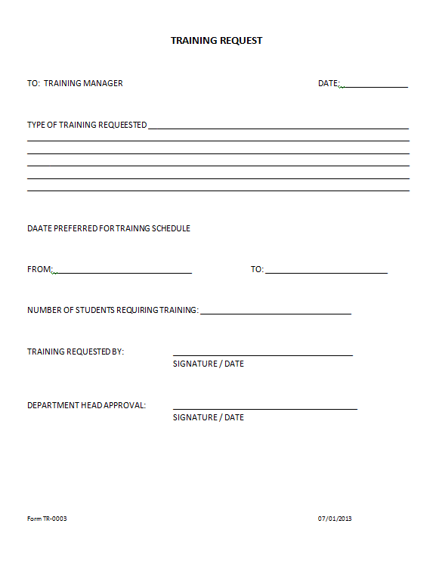

Instructions for completion of Training Request - Form TR-0003:

1. DATE: Date of the request.
2. TYPE OF TRAINING REQUESTED: Course type required.
3. DATE PREFERRED FOR TRAINING SCHEDULE FROM: Requested time for course to start.
4. DATE PREFERRED FOR TRAINING SCHEDULE TO: Requested time for course to finish.
5. NUMBER OF STUDENTS REQUIRING TRAINING: Number of pupils requiring training.
6. TRAINING REQUESTED BY: Person requesting training course.
7. DEPARTMENT HEAD APPROVAL: Person approving the course request.

Training Activity Report Form TR-0004

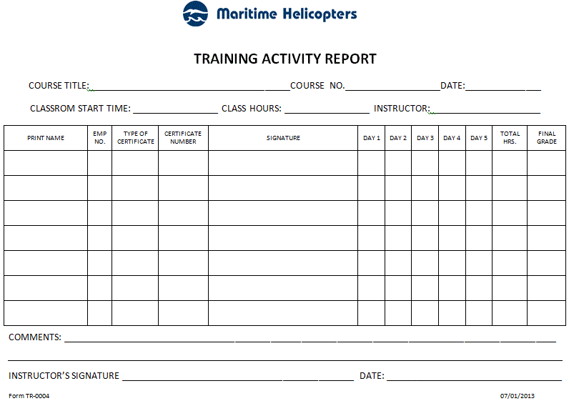
Instructions for completion of Training Activity Report Form TR-0004:

1. COURSE TITLE: Title of Course for the activity report.
2. COURSE No: Assigned Course number.
3. DATE: Date of the activity report / date of course.
4. CLASSROOM START TIME: Course beginning time.
5. CLASS HOURS: Hours of course attendance.
6. INSTRUCTOR: Name of Instructor/s.
7. PRINT NAME: Name of course attendee.
8. EMPLOYEE NUMBER: Attendees employee numbers.
9. TYPE OF CERTIFICATE: TBA
10. CERTIFICATE NUMBER: TBA
11. SIGNATURE: Attendees signature.
12. DAY 1 through DAY 5: Hours of course attendance.
13. TOTAL HOURS: Total hours for the 5 day period.
14. FINAL GRADE: Grade awarded.
15. COMMENTS: Instructors comments on class.
16. INSTRUCTOR’S SIGNATURE: Signature of instructor.
17. DATE: Date of course completion.

Training Verification - Form TR-0005
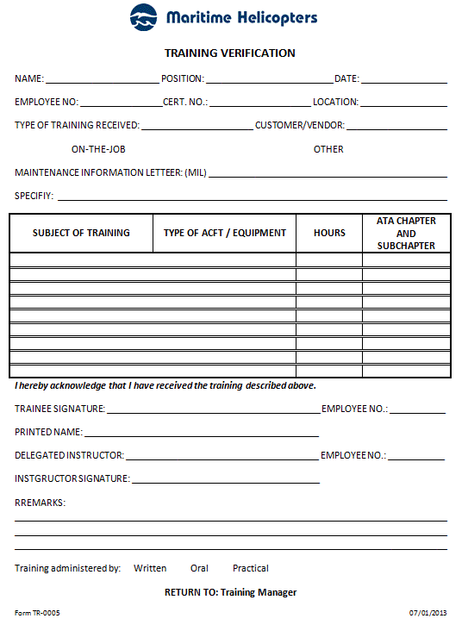

Instructions for completion of Training Verification Form TR-0005:

1. NAME: Full name of trainee.
2. POSITION: Trainees employment position.
3. DATE: Date of completion of the Training Verification.
4. EMPLOYEE NO.: Employees MHI employment number.
5. CERT. NO.: Employees certificate number, if any.
6. LOCATION: Location where the training took place.
7. TYPE OF TRAINING RECEIVED: Initial / Re-current
8. CUSTOMER: Customer provided training – check box.
9. ON-THE-JOB: OJT training – check box.
10. OTHER: Check box and specify in either 11 or 12.
11. MAINTENANCE INFORMATION LETTER: (MIL) as issued by MHI.
12. SPECIFY: If 10 is checked, specify type of training received.
13. SUBJECT OF TRAINING/ TYPE OF ACFT/ EQUIPMENT: Course name / aircraft /equipment type for training received.
14. HOURS: Course/Training hours expended.
15. ATA CHAPTER AND SUBCHAPTER: ATA chapter and sub chapter content for the course, if applicable.
16. TRAINEE SIGNATURE: Signature of trainee receiving the course.
17. EMPLOYEE NO.: Employee Number of trainee receiving the course.
18. PRINTED NAME: Printed Name of trainee receiving the course.
19. DELEGATED INSTRUCTOR: Print Instructors Name.
20. EMPLOYEE NO.: Instructors MHI employee number, if applicable.
21. INSTRUCTOR SIGNATURE: Instructors signature.
22. REMARKS: Any remarks regarding the course – to be filled out by the instructor.
23. TRAINING ADMINISTERED BY: Check type of instruction technique employed for the course.

Training Course List - Form TR-0006
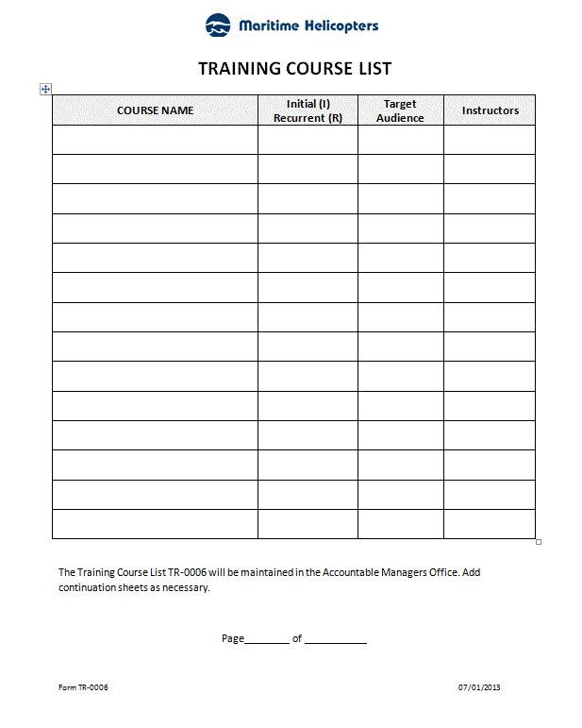
Instructions for completion of Training Course List Form TR-0006:
1. COURSE NAME: Course Name / number assigned to the course.
2. Initial (I), Recurrent (R): Indicates the course periodicity.
3. Target Audience: Course audience suitability, (i.e. Technician, Inspector, Materials Personnel (i.e. Purchaser/Planner, All, etc).
4. Instructors: Assigned instruction provider for the course.
5. Enter page number (i.e. Page 2 of 3)
6. Enter total number of pages (i.e. Page 2 of 3)

Course-Lesson Information - Form TR-0007
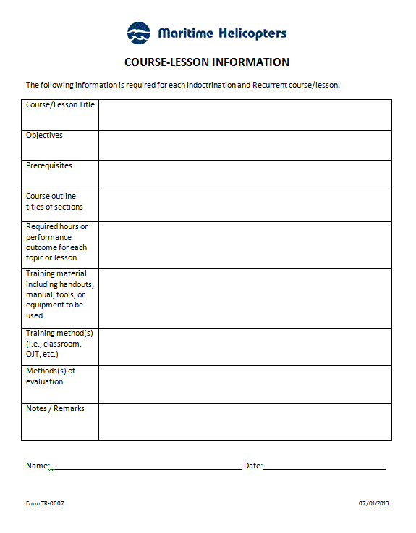

Instructions for completion of Course-Lesson Information Form TR-0007:

1. Course/Lesson Title: Enter Course / Lesson Title / Part course number.
2. Objectives: Enter Reason/requirement for the course creation.
3. Prerequisites: Enter any prerequisite required prior to undertaking course.
4. Course outline titles of sections: List multiple section titles.
5. Required hours or performance outcome for each topic or lesson: Instruction hours or achievement % to pass course.
6. List of training materials, (i.e. handouts, manuals, tools or equipment to be trained on).
7. Method of training, (i.e. classroom, OJT, self study, case study, computer based training, distance learning or off site/OEM).
8. Chief Inspector will evaluate all initial training courses as necessary.
9. Enter any Notes/Remarks for comments and or improvements.
10. Name of person initiating course lesson form.
11. Date of form originating.

Employee Skill Survey - Form TR-0008
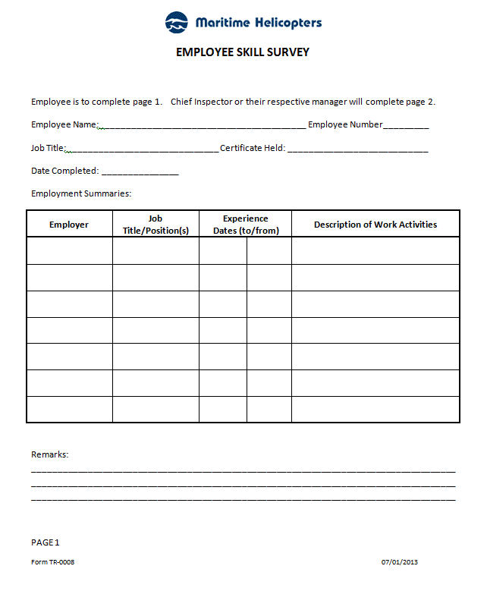
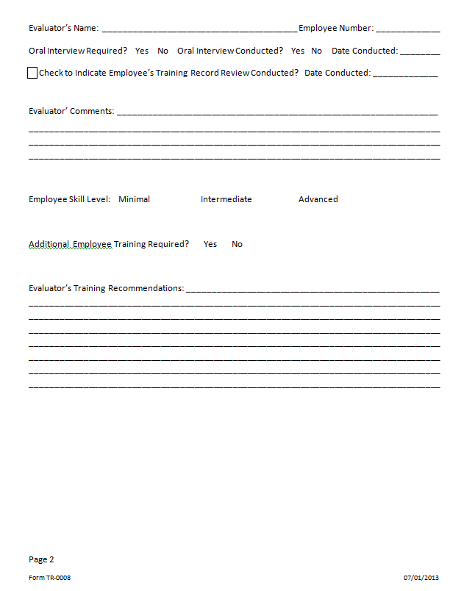

Instructions for completion of Employee Skill Survey Form TR-0008:

1. Employee’s name (i.e. John Jet, etc.)
2. MHI employee number
3. Present job title/position (i.e. AMT, Lead, Inspector, etc.)
4. Type and number of 14 CFR Part 65 Certificate held (i.e. A&P 12345678, Repairman 1234567, etc.)
5. Date that employee completed page 1 of form
6. Provide name of employer (i.e. ABC Airlines, XYZ Repair Station, etc.)
7. Provide job title/position(s) held regarding employment (use multiple lines if required)
8. Enter beginning date of employment for positions held
9. Enter ending date of employment for positions held
10. Describe work activities conducted for relevant positions
11. Enter any additional details pertaining to work activities conducted, relevant experience, specialized skills or training that will assist evaluator in determining employee skill-set and overall experience level
12. Name of individual conducting skill survey evaluation
13. MHI employee number of individual conducting skill survey evaluation
14. Indicate if oral interview is required by selecting the appropriate box (i.e. √ or X) Yes or No
15. Indicate if oral interview was conducted by selecting the appropriate box (i.e. √ or X) Yes or No
16. If oral conducted, enter date
17. Check box (i.e. √ or X) to indicate that employee’s training records have been reviewed
18. Enter date that employee’s training record was reviewed
19. Evaluator will enter comments pertaining to evaluation (i.e. employee demonstrates a thorough knowledge of BHT 407, AS350 aircraft for both avionics and system maintenance, etc.)
20. Evaluator will check appropriate box (i.e. √ or X) to indicate if employee is of Minimal, Intermediate, or Advanced skill level
21. Evaluator will select appropriate box (i.e. √ or X) Yes or No to indicate if employee requires further training
22. Evaluator will provide details of training recommendation(s) (i.e. Employee will require a BHT 407 General Familiarization class, etc.)

Repair Station Needs Assessment - Form TR-0009
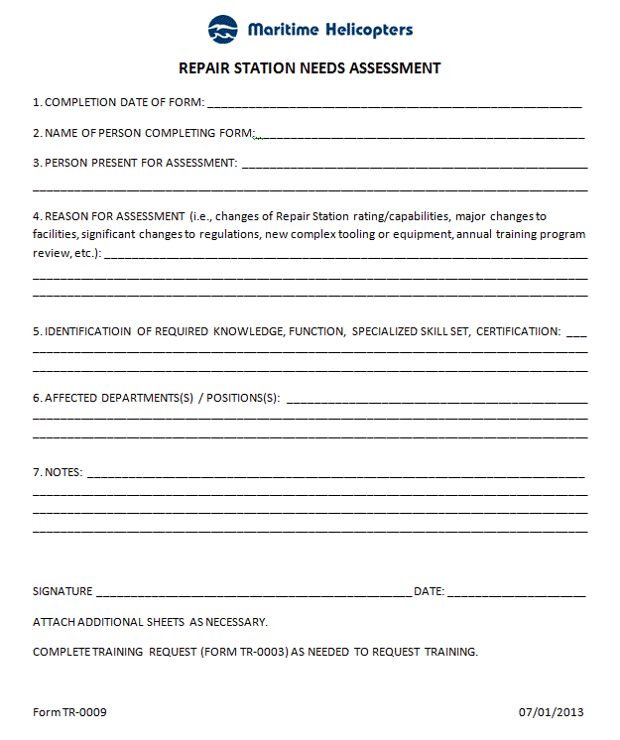
Instructions for completion of Repair Station Needs Assessment Form TR-0009:
1. Date form completed.
2. Name of person preparing the form.
3. Individuals present for the assessment.
4. Enter applicable reason for assessment from item 4. If form is being completed for training program annual review, place Annual Review in this field.
5. Insert applicable criteria, (i.e. person performing maintenance, preventative maintenance and /or alteration/inspection functions, skills, experience and training of current employees, assessments of employees being assigned new tasks, return of employee to tasks after extended period, introduction of new regulations, procedures, equipment and record keeping procedures or an upcoming change in nature of basic repair station capability).
6. Departments and positions affected.
7. Add notes as/if required to further document pertinent details discussed during the assessment process including any assigned actions or items requiring further follow-up.
8. Signature of Chief Inspector or his/her designee.
9. Date of signature by Chief Inspector or his/her designee.

Instructor/Trainer Evaluation - Form TR-0010
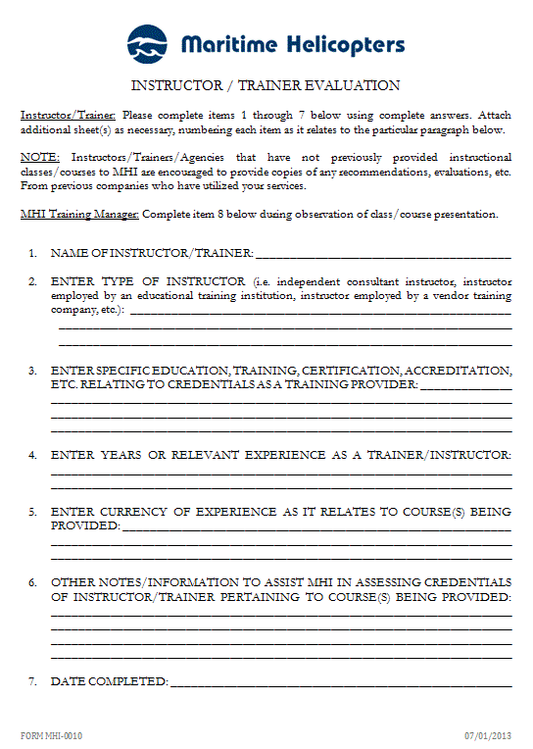
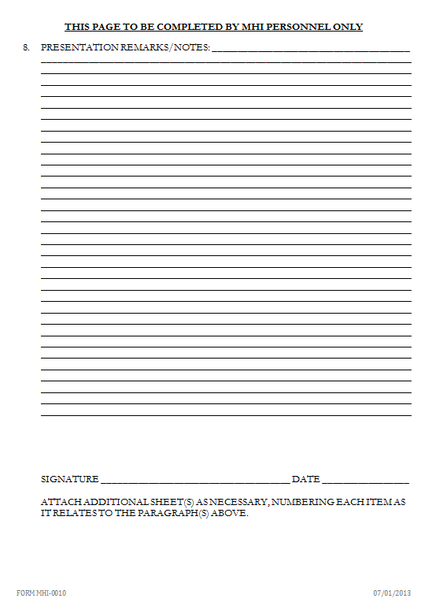

Instructions for completion of Instructor / Trainer Evaluation (Form TR-0010) entries:

1. Enter name of individual conducting the instruction/training.
2. Enter type of instructor (i.e. independent consultant instructor, instructor employed by an educational training institution, instructor employed by a vendor training company, etc.).
3. Enter specific education, training, certification, accreditation, etc. relating to credentials as a training provider. Please provide copies of certification, accreditation, diploma, etc.
4. Enter years of relevant experience as a trainer/instructor.
5. Enter details of currency of experience as it relates specifically to course/class being provided. Details requested are intended to assess the currency of experience of the instructor/trainer in relation to the course/class to be conducted.
6. Enter any other information that would assist MHI in assessing the credentials of the instructor/trainer pertaining to the course(s) being provided (i.e. recently provided instruction of this same course (B737-300/400 General Familiarization) to ABC Airlines in Anytown, USA on July xx, 20xx).
7. Enter date form was completed by instructor/trainer (or if performed via a phone or personnel interview, date of interview).
8. Enter details of observations made during a class/course presentation including attributes such as the individual’s subject knowledge/expertise, class/student interaction, quality of aids/materials, presentation style, demeanor, etc. This information shall include the subject, date, location of class and date. When possible and/or practical, this observation may be accomplished by observation of the instructor during a presentation to non-MHI personnel.
9. Signature of Chief Inspector or his/her designee.
10. Date of signature by Chief Inspector or his/her designee.

Course Evaluation - Form TR-0011
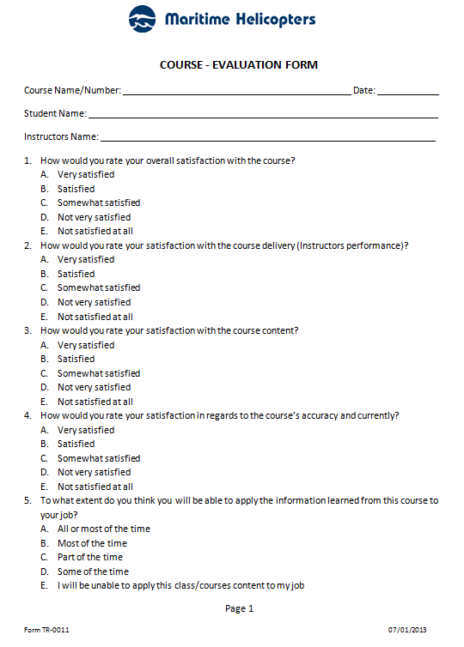

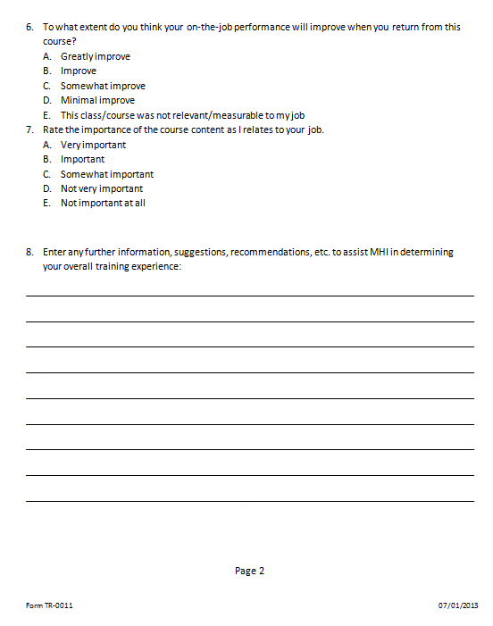
Instructions for completion of Course-Evaluation (Form TR-0011) entries:

1. Enter Course Name or Number.
2. Enter Date of the course completion.
3. Enter Name of the Student completing the evaluation form.
4. Enter Name of the Instructor giving the course.
5. Answer all questions and circle the relevant answer letter.
6. Enter any notes or other information to assist MHI in determining your overall training experience

Training Activity Make Up Form - TR-0012

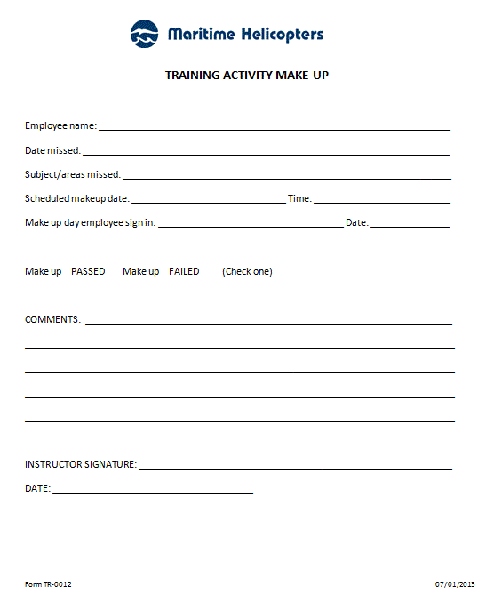
Instructions for completion of Training Activity Make Up (Form TR-0012) entries:

1. Name of employee (i.e. John Jet, etc.)
2. Date of training course missed
3. Subject / areas missed
4. Date scheduled for make up
5. Time scheduled for make up
6. Employee must sign in
7. Employee must enter correct date of make up
8. Instructor will circle the appropriate word to indicate PASSED, FAILED
9. Instructors comments entered as applicable
10. Instructors signature
11. Date of makeup

