Maritime Helicopters Twin Otter Pilot RII Training Program

Introduction: 1.0 HRS with video and questions?

The purpose of this program is to assist Maritime Helicopters, and our team members maintain the exceptional safety and readiness that our clients deserve. It is by no means intended to transition pilots into mechanics, the intent is to add an extra layer of safety and flexibility to our maintenance program and to reduce the possibility of human error. During this training we will discuss the specific required inspection items that we will encounter during routine and non-routine maintenance of the aircraft. No pilot will be asked or coerced to sign off a task they are not trained on, or not comfortable with. There will be no repercussions from Maritime Helicopters management if a pilot declines to perform a RII task that they feel is above their level of system comprehension and training.
An initial 16 hours of training is required for the pilot to obtain an FAA issued repairman certificate. This course will by no means cover every task that your repairman certificate will be used for, and ongoing training will be provided by the mechanic on duty prior to the task being performed during both routine and non routine maintenance.

Repairman Authorization

Your repairman authorization is an FAA issued authorization to inspect, post completion, specific maintenance tasks that have been performed by the mechanic. The Maritime Helicopters DHC-6-400 RII Training Program has been approved by the administrator, and upon completion of this training you will be issued your repairman authorization certificate. The certificate issued for this program is limited in scope to the criteria described in CFR 65.101(a)(3), and is legally authorized as outlined in CFR 65.101(a)(5)(ii), and can only be utilized for work performed for Maritime Helicopters DHC-6-400 aircraft. Your license is invalid and should be surrendered to your supervisor upon separation from Maritime Helicopters.

§ 65.101 Eligibility requirements: General.
(a) To be eligible for a repairman certificate a person must -
(1) Be at least 18 years of age;
(2) Be specially qualified to perform maintenance on aircraft or components thereof, appropriate to the job for which he is employed;
(3) Be employed for a specific job requiring those special qualifications by a certificated repair station, or by a certificated commercial operator or certificated air carrier, that is required by its operating certificate or approved operations specifications to provide a continuous airworthiness maintenance program according to its maintenance manuals;
(4) Be recommended for certification by his employer, to the satisfaction of the Administrator, as able to satisfactorily maintain aircraft or components, appropriate to the job for which he is employed;
(5) Have either -
(i) At least 18 months of practical experience in the procedures, practices, inspection methods, materials, tools, machine tools, and equipment generally used in the maintenance duties of the specific job for which the person is to be employed and certificated; or
(ii) Completed formal training that is acceptable to the Administrator and is specifically designed to qualify the applicant for the job on which the applicant is to be employed; and
(6) Be able to read, write, speak, and understand the English language, or, in the case of an applicant who does not meet this requirement and who is employed outside the United States by a certificated repair station, a certificated U.S. commercial operator, or a certificated U.S. air carrier, described in paragraph (a)(3) of this section, have this certificate endorsed “Valid only outside the United States.”

What is a Required Inspection Item?

RII items are specific inspections of any maintenance action that, if improperly done, could result in immediate danger to an aircraft. If you are rigging flight controls, installing a propeller, or performing another maintenance action that affects flight critical systems then it’s certain that they involve an RII.

RII is defined in Part 135.427 and Part 121.369 of the FARs.
An RII item can be as simple as leak checking a fuel line after maintenance, to something as complex as double checking that all fuel lines and pneumatic lines have been torqued and safetied, nuts have cotter keys, and bolts have safety wire after an engine installation. In the event of a major system such as an engine being changed, it is likely that extra maintenance would be sent up to assist with this process, relieving a pilot of any RII duties, but a pilot that feels comfortable with what they are looking at may be asked to RII something as involved as a fuel control.
Regardless of the complexity of the specific task, a detailed explanation and overview of what the processes involved in the RII task to be performed will be discussed and shown prior to removing the component being replaced, or system being adjusted/rigged. This would be the best time for the pilot/repairman to accept or decline the task, so that an additional maintenance team member can be assigned. There is no pressure for you to accept this responsibility if you are not comfortable with the task; additional training will be accomplished if necessary. The purpose of this training is to help you feel comfortable inspecting aircraft system rigging and component installations. This information and education will travel with you throughout your career, and may even save your life someday.
Instructor Note: Show video for flight 5481 https://www.youtube.com/watch?v=LkObvOgPaZc

Discuss video. The pilot sees the elevators of this aircraft everyday. A simple preflight inspection after reading the squawk and the pilot could have noticed his elevator didn’t go stop to stop, was resting on the cables and not the stop, and 7 degrees, although not huge, may have been visibly noticeable if the pilot was alert, trained, and in tune to the maintenance performed on the aircraft the night before. Who is ultimately responsible for this accident? This accident is a culmination of human error.

Tool control program and calibration verification
1.0 HRS?
Several tools that a technician uses to inspect and repair aircraft systems are required to meet certain calibration criteria. Maritime Helicopters has a tool tracking and calibration system in place designed to reduce the chances of a technician using out of calibration or uncalibrated tools. Calibrated tools are usually marked with a calibration due date, and have some documentation as to when the tool was last calibrated, and when the next calibration is due. It is the responsibility of the technician using the tool, and the inspector signing off the RII to ensure that the tool being used for the task has current calibration. If the sticker is missing from the tool, the calibration can be identified with a master calibration list by identifying the tool by model and serial number. Tools that require calibration include, but are not necessarily limited to, torque wrenches, cable tensiometers, inclinometers, force gauge, and electrical test equipment.

Any time an inspector is required to verify that a calibrated tool is used for a specific task, the inspector should understand what the tool does, how the tool works, and how to properly use the tool. Take your time to ask questions, reference the manual to obtain a clear picture of what value the tools should be set at, and ask the technician to explain the process if it is new to you, or you need to re-familiarize yourself with the process. Above all, make sure you understand the exact part of the process you are being asked to observe/inspect, so that you have a clear understanding of what you are looking at.

Certain tools require special consideration while being utilized. Examples of this are when a tensiometer is being used, the system needs to be equalized so that excess pressure is not sitting on one cable more than another, like an elevator resting on it’s downward stop will cause the lower cable to read looser than the upper cable, this is why it is important to follow the steps outlined in the maintenance manual, and develop an understanding of how the system is built. Another example is an additional length being added to a torque wrench for access purposes. This additional length will change the actual torque value at the fastener and needs to be accounted for. A tools calibration without proper understanding of how the tool is used, is as worthless as an uncalibrated tool.
Another part of tool control is ensuring all tools used in these processes are accounted for. Tools left in aircraft cause damage, accidents, and can injure people on the ground if they fall out during flight.
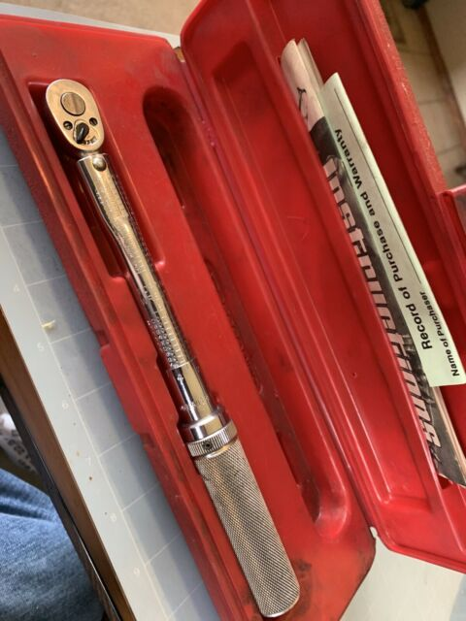
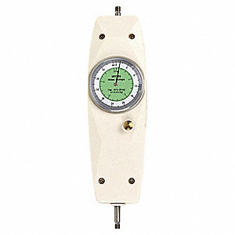

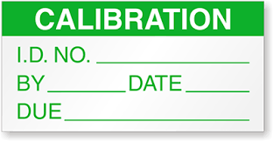
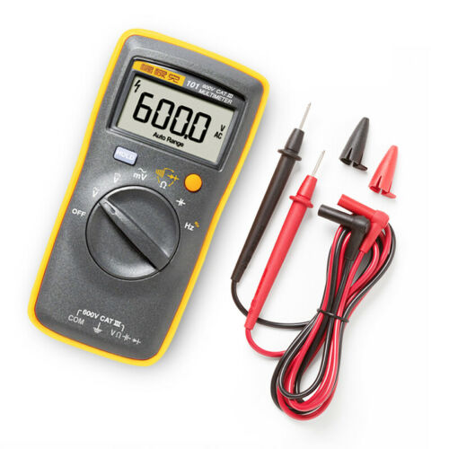
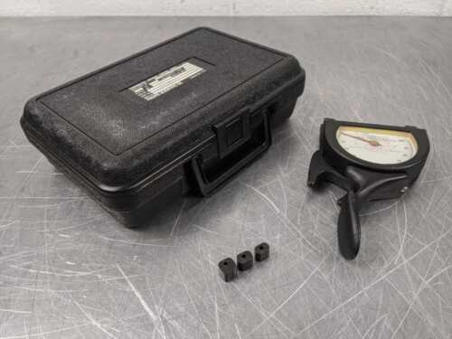
https://www.youtube.com/watch?v=dd0Z2PKUA-g
Inclinometer
Tensiometer
Force Guage
Multimeter
Torque Wrench
Commonly calibrated tools
Calibration Sticker
https://www.youtube.com/watch?v=NV1VToAqfX
Common Fastener Safety Methods and Practices
1.0 hrs
Critical fasteners in aviation and other fields are commonly installed with various safety locking methods. The safety method used depends on the application, location, and physical operation of the hardware being safetied. As an inspector you should feel comfortable recognizing hardware that requires a safety, and understand the proper way that the fastener safety is to be applied in the area you are inspecting. As a general rule, it is best to see, understand, and take note of the area and components you will be inspecting before the repair takes place, so you have a current reference as to what the job should look like when completed. If, during the initial familiarization of the area to be inspected doesn’t look like it was correctly done to begin with, discuss it with the mechanic. He will either agree that the last person to do the job performed it incorrectly, or will give you an explanation as to why the particular area is done the way it is, providing references from the manufacturer such as illustrated parts catalog, maintenance manual, ect. if necessary.

Cable adjustment and Turnbuckle Safety

During an inspection or repair of engine and control surface rigging the technician may be required to remove cable turnbuckle safeties in order to set the cable tension to manufacture specifications. As an inspector, you should be familiar with the concept of proper cable tension, routing, and final check of system rigging. During routine inspections specified in the CAMP, you may be asked to verify that systems are within specification, even though there is no actual work being done on the system. An explanation of the task being performed, manufacturer data will be provided, and the tools being used will be available for your inspection.

After a turnbuckle has been properly adjusted, it must be safetied. There are several methods of safetying turnbuckles. The clip locking method is the method you will run into on the Twin Otter. It is legal to utilize the wire wrapping method should the safety clips not be available at the time of the adjustment/repair.

Do not reuse turnbuckle clips or safety wire, they are single use items, and should be discarded after removal. Adjust the turnbuckle to the correct cable tension so that no more than 3 threads are exposed on either side of the turnbuckle barrel. Double check that the number of threads on each side of the turnbuckle are equal to ensure that the cable is not twisted.

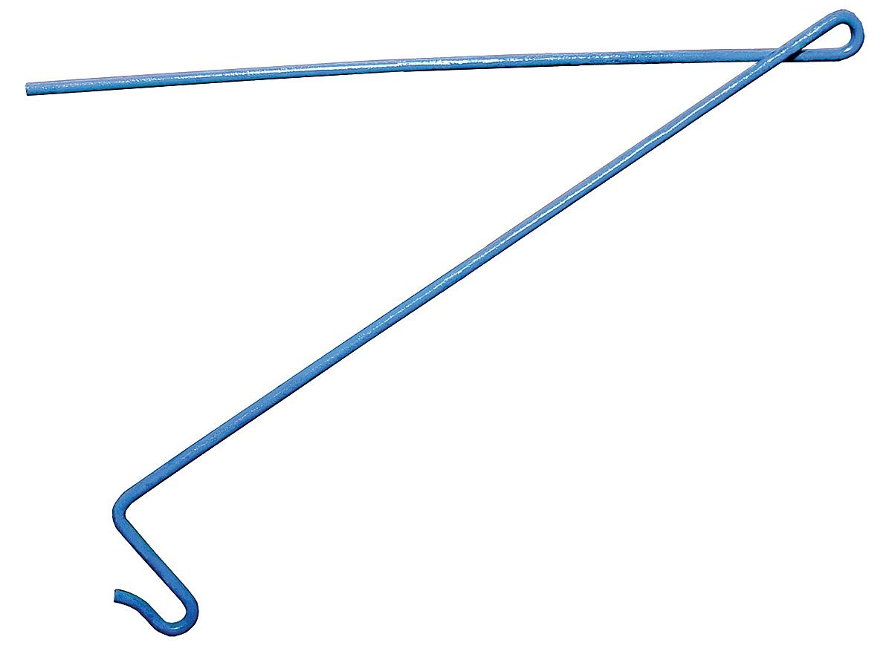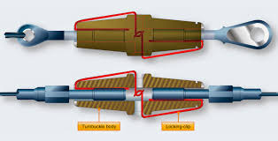

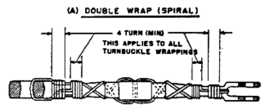

Drilled Head Fasteners

For fasteners such as bolts and screws that thread into a component or case and do not have a nut on the threaded portion, the head is drilled. Ensure these fasteners are safetied in a positive direction (wire pulling the bolt head tight), there is little to no slack in the safety wire, and there are at least 4 twists extending past the fastener or fastened point.

Hydraulic and pneumatic fittings

Some pneumatic and hydraulic fittings are safetied. As a general rule, if the fitting has a hole drilled through one of the corners, it should be safetied to a secure point such as another fitting, or to the line itself in a positive direction. Attached is a general overview of standard aircraft safety wiring methods. Familiarize yourself with these so that you have an understanding of what you are looking at on the aircraft.

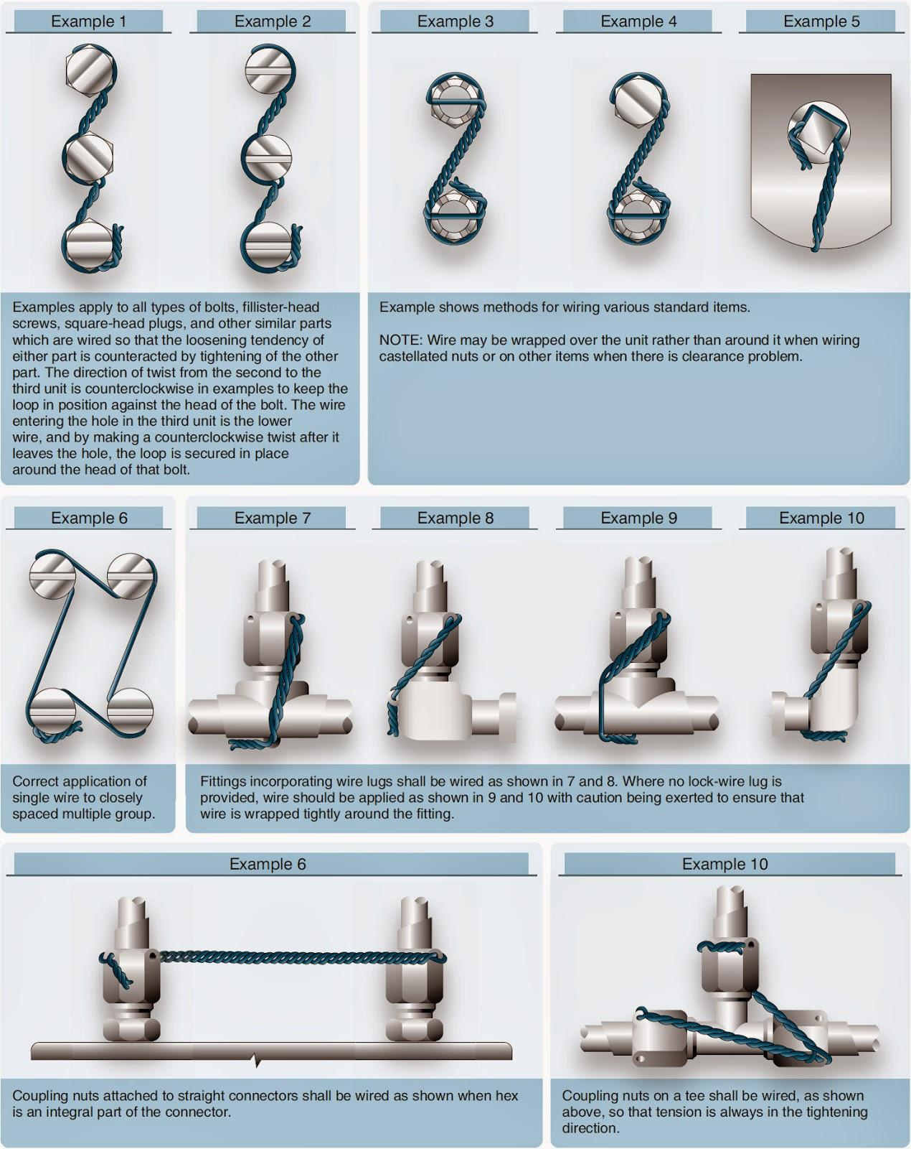

Drilled thread fasteners and clevis pins

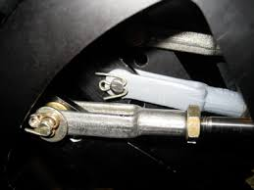
Fasteners with drilled threads are usually combined with castellated nuts and cotter pins to ensure the fastener does not come loose. There are a few acceptable methods of cotter pin installation. Depending upon the application, these bolts can be installed with very light to no torque, and safetied with a cotter key, or torqued to a specific value, and safetied. Light torque applications where components need to be able to rotate and move freely of each other, include landing gear links, ice shield doors, cowl flaps, ect. You may also see threadless fasteners called clevis pins in some of these applications.
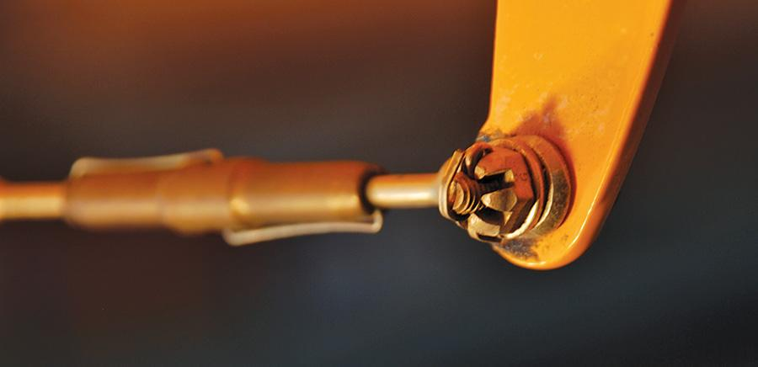
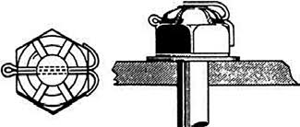
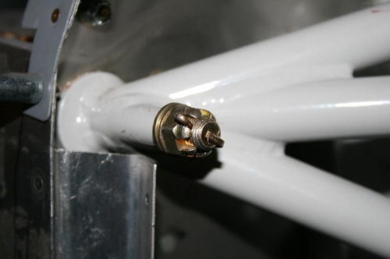
Clevis pin
Torqued and safetied
Left is unacceptable
Loose and free to rotate, safetied

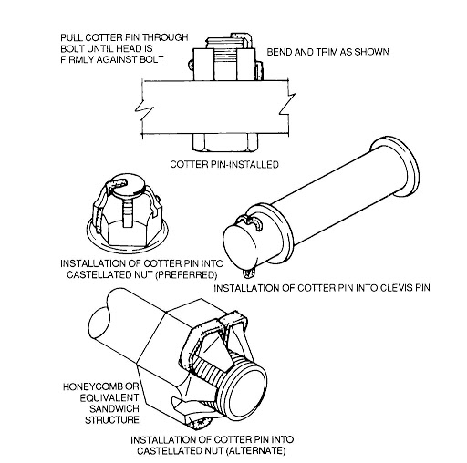
All acceptable methods, note the alternate one is locked into the castellations.
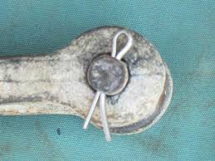
Unacceptable

https://www.youtube.com/watch?v=0LPRZPm_OzY

Undrilled Fasteners

Undrilled fasteners are often safetied using torque against a locking washer, by utilizing a locking nut, or using a jam nut. There are several different types of each of these locking devices, and which one used is determined by the manufacturer. These types of locking mechanisms are usually used in areas where rotational force is not likely to be applied to the fastener.
Lock washers will usually be placed directly under the nut, but on top of a flat washer in order to prevent galling of the contact surface, and should not be re-used due to their design.
Lock nuts are re-usable as long as there locking feature is still functional, but it is good practice to replace lock nuts in critical systems. Keep in mind there are several different types of locking nuts. As an inspector, you should take note of what was on the aircraft before the task has begun. One critical note on locking nuts is that nylon locking nuts should never be installed in areas of high heat.
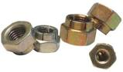
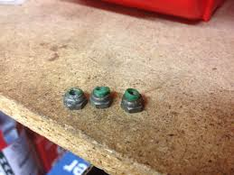
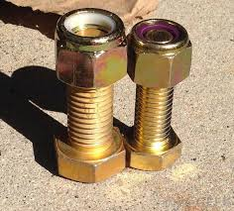
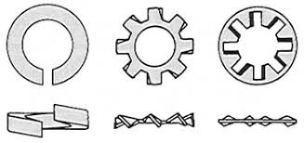
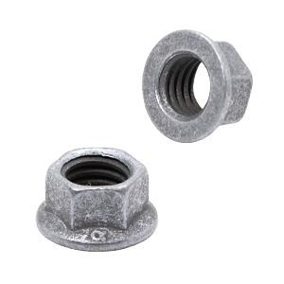
https://www.youtube.com/watch?v=fzaqRicBNDM
Nyloc in high heat area
Reduced diameter locknut
Lock washers
Nyloc Nuts
All metal locknuts
https://www.youtube.com/watch?v=5MBu8ysISp4

What to expect as an inspector

Now that you are familiar with the basics of what you will be looking at, it is time to learn how to apply this knowledge to safely and effectively inspecting the work performed by the technician, what to do if you think there is an issue with the work performed, and how the forms used by Maritime Helicopters are formatted to do document your involvement in the work performed.

What is the actual job of an RII inspector?
The job function of an inspector is to inspect work performed by the technician. Some tasks will require the inspector to watch certain processes, and some will be post-completion inspection. Either way, it is a good idea for the inspector to look at the work area prior to the task, in order to understand what it should look like after the task.

Clear to close

When working in certain areas such as fuel tanks, inside wings, and under panels where the technician has been working, the inspectors job will be to take one last good look inside the area, using inspection tools such as flashlights and mirrors as necessary, to ensure that there is no FOD left behind from the technician prior to sealing the area from further inspection.

Leak Check

After the technician has completed replacing fuel, oil, and hydraulic lines or components, the system needs to be operated as it normally would and any component that was worked on during the process will be visually verified to be tight, leak free, and the system operates as it should.

Operational Check

After the technician has completed working on flight critical systems, the inspector will verify that the system operates correctly.

Rigging Check

Any time cables, pulleys, and push pull tubes in a critical aircraft system are adjusted or replaced, a system rigging check is necessary. These checks can be fairly easy, or quite involved. Each situation will be different and include using the maintenance manual, measurement tools, complete ground checks, and a check flight. Any time there is an adjustment to these systems it is imperative that the inspector understand how the system operates, the procedure the technician used to rig it, and how to check the final outcome of these adjustments.

Engine rigging checks will include

Pre-flight inspection of systems prior to check flights,

Run up procedures after engine/propeller/control maintenance

Quick inspection of flight control rigging post maintenance (How does it feel from the cockpit, are the controls traveling in the appropriate direction in regards to the movement of the yoke or rudder pedals, do they have full travel (Stop to stop on most aircraft, but not all) are they symmetrical? Is the trim neutral when indicated? Does the trim travel in the correct way (Tab moves up to drive the control surface down)

Quick inspection of engine rigging post maintenance. (Cables may be tensioned and safetied correctly, but is there any dragging/binding that might indicate the mechanic/inspector missed the cable dragging on top of a pulley guard, ect.

Specific Systems relative to the Twin Otter such as control stops, basic overview of rigging procedures, cable safeties, and deflection of flight controls

CAMP inspection item explanation and overview, explanation that a lot of this will have initial/ongoing training just prior to the inspections.

Instructor training outline so that the program stays relatively the same from instructor to instructor, such as panels to remove, ect.

Some generic form of training completion and a cute little certificate?

Add some fufu pictures of airplanes, bulk it up with whatever to make an acceptable amount of hours. Test it out on Mike Moore for a final test.
https://www.youtube.com/watch?v=7ddwrcBnoy0

