07/06/2020

Maritime Helicopter, Inc. has trained and appointed the following Airmen as a Part 135 RII Repairmen/Mechanic Trainer on the DHC-6-400 aircraft;

Chris Stout

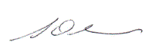
Steve Slade
Director of Maintenance/ Part 145 Accountable Manager
Maritime Helicopters, Inc.
907-235-7771 Phone
907-235-7773 FAX

